Organised by
WALES SYNOD CYMRU
and the Conwy and Prestayn Circuit
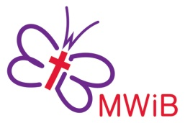
Methodist Women in Britain
DISTRICT DAY
A LENT JOURNEY in 2024
Exploring Lent and Holy Week
Led by District President
Mrs Norma Boocock with
Mrs Frances Williams and Mrs Kathryn Williams
AT
St David’s Methodist Church
Mostyn Avenue, LL30 1YY
ON
Saturday 16th March 2024
10am-3.15pm
Soup lunch and refreshments provided
For more information contact denise.creed@methodist.org.uk
ALL MWiB EVENTS ARE OPEN TO ALL

