CIRCUIT MISSION STATEMENT
Our aim, as the people called Methodist in this place is to ‘seek first the kingdom of God’ (Matthew 6:33) and to inspire others to do the same.
Our vision is to ‘put compassion first’ and it is through the participation of our churches in God’s mission that this vision is realised.


Circuit News

For members of our circuit and friends, please find the latest circuit news......
Remember that not everyone has access to the internet. Perhaps there are visitors to your church who may not be on our circulation list...
Please feel free to print out a few copies to spread the news!
Some churches have also included a link in their own newsletter which allows people to click to access the bulletin directly! Great idea!

District Leadership Team have sent this through to share with members of our church councils and Circuit Meeting:

Trustee Duties – Webinar Thursday 5th November at 12pm, online
This is a free webinar hosted by the Charities Engagement Team available to faith, international and Higher Education Provider charities.

This webinar will cover what your trustee duties are. It will consider:
• What being a trustee means;
• The six main charity trustee duties;
• The role of the Charity Commission, (including when things go wrong);
• Common issues that can arise and how to avoid them;
• Signposting to where you can get further help and guidance.

Learn more: https://bookwhen.com/cetevents/e/ev-snkgf-20261105120000

The next Circuit Peace and Justice Group is on Tuesday November 3rd at 7pm and will be held in St John's Llandudno Church Fellowship room at 7pm

The agenda will include reporting on actions taken from the last meeting concerning our practical responses to the National Emergency Briefing Film as well as consideration to other issues the group wishes to pursue.

We now have 15 in the group but are keen to not exclude anyone. Why not come along or request minutes if you cannot.

Contact
Graham Morgan gramorg1@gmail.com

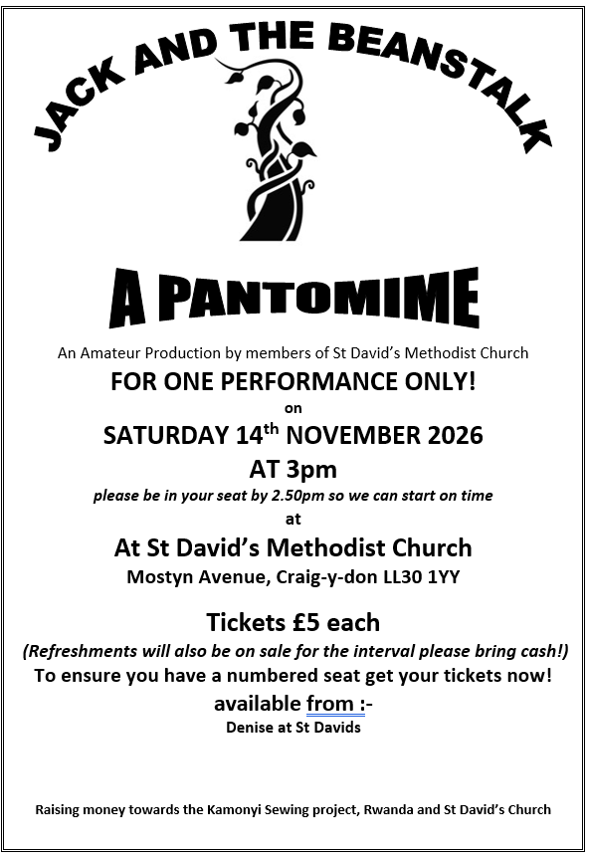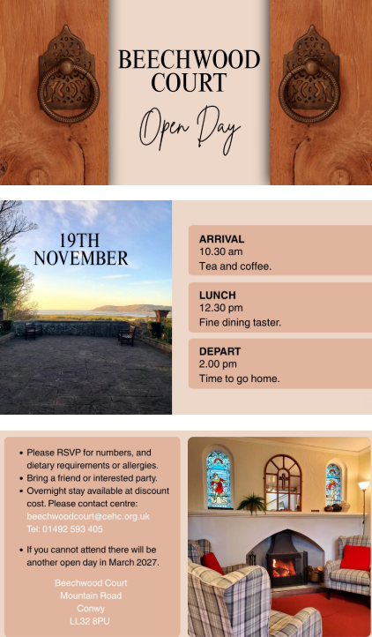
Dreaming Beyond
By Methodist Learning Network Online event
Tuesday 10 November • 1:30 PM - 3 PM GMT
What happens when a chapel lets go of old assumptions and makes space for relationships, community and pilgrimage?

Dreaming Beyond:
A conversation for small and rural churches Featuring Celtic Chapel, Crewe by Farndon
Join us as we hear the story of Celtic Chapel, a rural Methodist chapel that has discovered new life by focusing on people rather than programmes. What began as a small playgroup grew into a web of relationships that has shaped a vibrant community of faith.
Along the way, a children's ministry evolved into a place where parents stay, connect and journey together, and a local playgroup opened doors into schools and neighbouring villages.
Despite the challenges of their location and limited resources, Celtic Chapel has found creative ways of nurturing faith through hospitality, shared meals, nature, pilgrimage and deep community connections.
Their remarkable journey includes a three-year pilgrimage along the North Wales Pilgrims Way, bringing together people aged 8 to 80 in a shared spiritual adventure.
Formerly known as Crewe by Farndon Methodist Chapel, the congregation embraced a Celtic Christian identity as they reflected on their calling to live out faith in everyday life, rooted in creation, spirituality and hospitality.
Their story offers inspiring insights into how churches can be faithful, fruitful and deeply connected to their communities by focusing on relationships and discerning what really matters.Come and be encouraged, challenged and inspired as we explore what it means to prune for faithfulness and discover new possibilities for mission and ministry.

New People New Places North Wales

Our new Distrcit “New People New Places” Pioneer, Martin Daws has shared dates for some of the forthcoming “Open Mic” Events.

Songs of Life Llandudno will be Sunday November 22nd at 2-4pm in Providero Coffee House.
Hope you can join us!

Confirmed dates for our inaugural events:

Quaystone Connah's Quay 11th November 7-9pm
Domu Kafe Bangor 19th November 7-9pm
Providero Coffee House Llandudno 22th November 11 2-4pm

www.martindaws.co.uk

Representative Synod

This will now be held on Zoom on Saturday 17th April between 10am and 1pm.

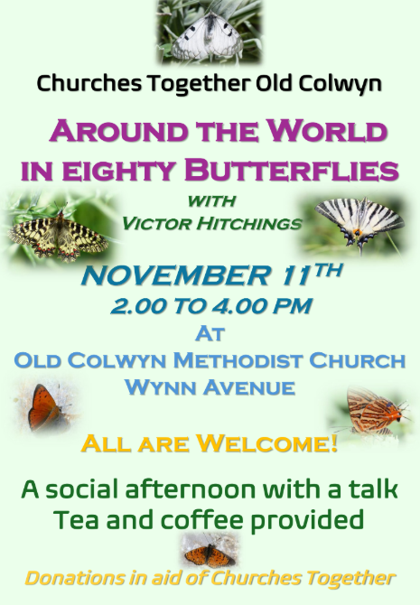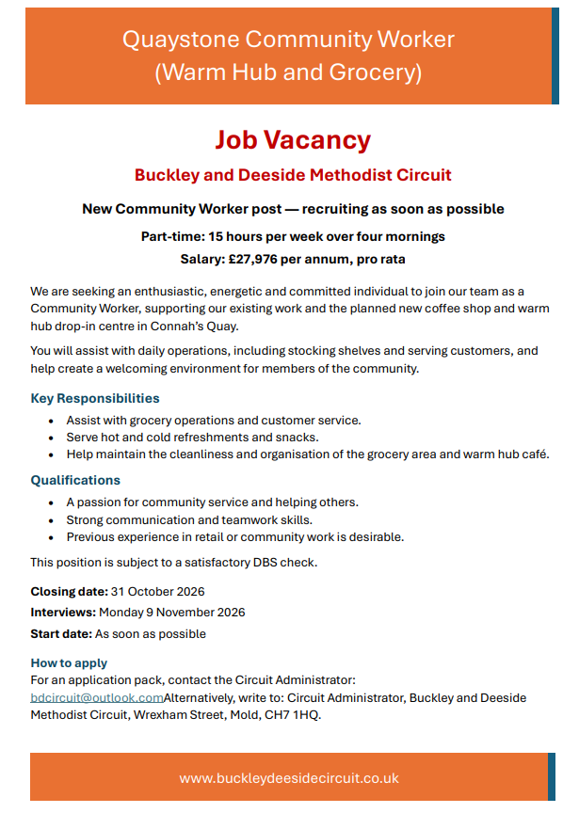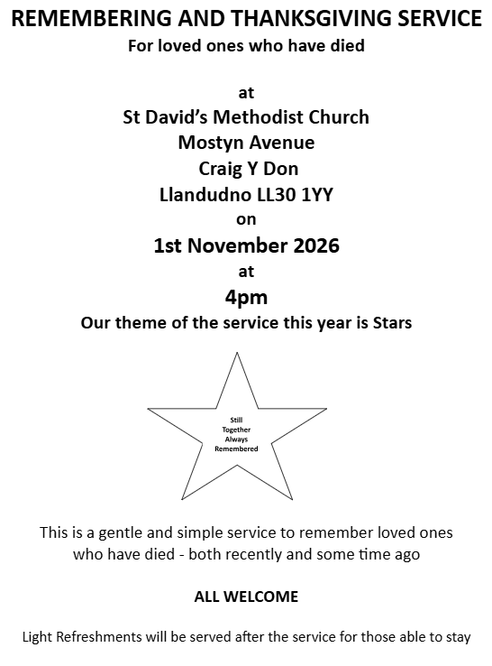
Circuit Magazine
We’d love you to be part of the next edition of Circuit Magazine—so get those ideas flowing!
Ideas to Get You Started
· Spread the word about an upcoming event happening in your church or surrounding area.
· Share an announcement or invite others to offer their time, practical support or prayers
· Offer a reflection the Lord has placed on your heart for friends across our sister churches
Ready to Join In?
Have an idea, a question or something ready to share? We’d be delighted to hear from you!

Street Pastors
If you would be interested in volunteering either as a Pastor or as part of the prayer team,

Llandudno Cytûn is considering setting up Street Pastors to support the town’s ‘Purple Flag’ status for the night-time economy. The proposal is for the Street Pastors not to operate all year round, but seasonally over Easter, Spring Bank holidays, the 6-week summer holiday period, October half term and Christmas/New Year. A Street Pastor team of 4-6 volunteers would be out on a Saturday night between 11pm and 4am, supported by a prayer team meeting in a church building over the same period.

Street Pastors on duty are identifiable by their uniform, offering a peaceful, practical, listening and non-judgemental presence on the night time streets. Training is provided for volunteers, some in person some online, and covering the Christian ethos of the programme as well as the cultural knowledge and practical skills needed to engage safely with new situations and contexts.

Cytûn will only be able to offer this witness to Llandudno if there are enough volunteers from at least four churches who are willing to train and be involved. Please please contact Mary Jones at St Johns Llandudno know if you would be interested in joining either the team on the street or the prayer team.

A Chat About Growing Older in Wales
22nd April at 2pm
Come along to meet Kay Hennessy from the Older People’s Commissioner for Wales team and find out how the Commissioner speaks up for older people and protects their rights.
There will be a chance to share your experiences, talk about what makes life better and suggest things you would like to see change.
The team is also keen to hear about the benefits and challenges of growing older in rural Wales.
Please contact Hayley at the Circuit office if you would like to come along.
Everyone welcome — come along and have your say!

Dates for your Diary
Deadline for articles for the circuit Magazine  Please send your contribution to Maria Carter or Liz Royle- cpmclayworkerlr@gmail.com) |  | 15th November
Free Training for Pastoral carers  Online event from the Methodist Learning Network |  | Wednesday 4th November-Wednesday 25th November  2 PM-4 PM  Link to register is here
Adventures in Worship Workshop |  | Saturday 7th November 2026  St David's Methodist Church, Craig-y-don
USEFUL TO KNOW….
Superintendent | Rev Dr James Garnett  01492596006 |  | james.garnett@methodist.org.uk
Deacon Linda Brown | Deacon Linda Brown  01745 823732 |  | deaconlindabrown@gmail.com
Outreach worker | Liz Royle  07866177832 |  | cpmclayworkerlr@gmail.com
Childrens’ & Families worker | Jodie James  07886177560 |  | cpmclayworkerjj@gmail.com
Circuit Finance Officer | Paula Hammond  01492878447 |  | cpmfinance2021@gmail.com
Circuit Administrator / Safeguarding | Hayley J. Allport  014920860439 |  | cpmcoffice2@gmail.com

