CIRCUIT MISSION STATEMENT
Our aim, as the people called Methodist in this place is to ‘seek first the kingdom of God’ (Matthew 6:33) and to inspire others to do the same.
Our vision is to ‘put compassion first’ and it is through the participation of our churches in God’s mission that this vision is realised.


Circuit News

For members of our circuit and friends, please find the latest circuit news......
Remember that not everyone has access to the internet. Perhaps there are visitors to your church who may not be on our circulation list...
Please feel free to print out a few copies to spread the news!
Some churches have also included a link in their own newsletter which allows people to click to access the bulletin directly! Great idea!

BIBLE MONTH: PHILIPPIANS


You are very welcome to join this year’s Circuit Bible Studies, which will focus on Paul’s Letter to the Philippians.

The Studies will be held at St David’s Church in Craig-y-Don. There is a choice of days and times: you can either come on Monday afternoons (2.30 to 4.00 p.m.) or Thursday evenings (7.30 to 9.00 p.m.). (Or you can switch between sessions, if that is more convenient for you.) The dates will be:

Thursday evenings Monday afternoons
Session 1: July 2nd July 6th
Session 2: July 9th July 13th
Session 3: July 16th July 20th
Session 4: July 23rd July 27th

David Lamb will lead the sessions. He will give a short introduction to each session. We will then split into small groups to study particular sections of Philippians, using simple-to-follow booklets. We will also be encouraged to read through the whole of Philippians for ourselves at home, using a Reading Plan.
If you would like to join in, could you please let David know by email or phone, so that he can make sure that there are enough booklets for everybody. Thank you.
Email: david.a.lamb@btinternet.com
Phone: 01492 549111

“This is my prayer: that your love may abound more and more in knowledge and depth of insight.” (Philippians 1:9)
Disability Awareness Sunday 2026

Churches across the UK are being invited to take part in Disability Awareness Sunday 2026, with the release of a free, creative new resource available to download from Christian charity “Through the Roof” (www.throughtheroof.org).
The 2026 theme, ‘One Body, Many Parts’, draws on 1 Corinthians 12 and celebrates the truth that the Church is not complete without disabled people. The official date is 27 September 2026, though churches are encouraged to take part on any Sunday that works for them.

Visit of the President and Vice-President of the Methodist Conference

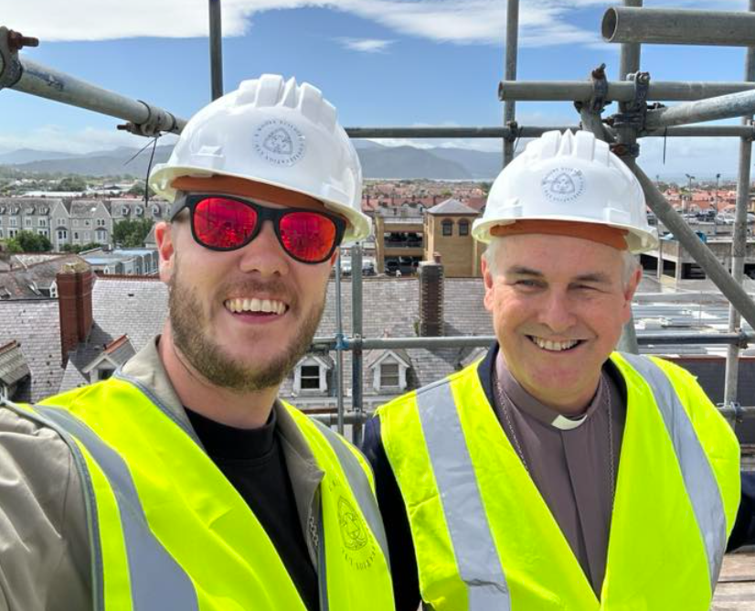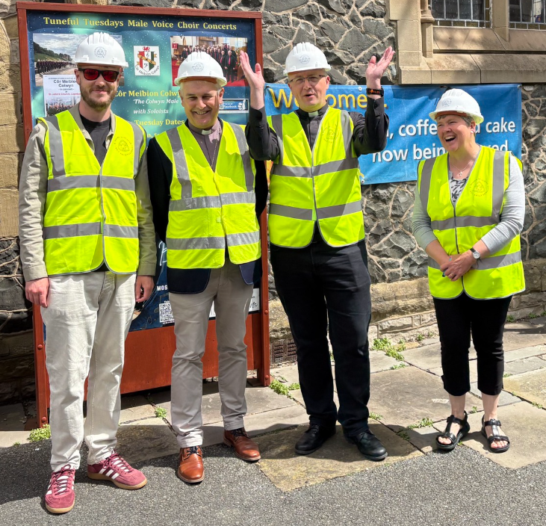
At a well-attended gathering at St John’s, 41 people enjoyed the thoughtful and strategically aware reflections of the President and Vice-President of the Methodist Conference.
Basing his comments on Chapter 13 of the First Epistle to the Corinthians, the President emphasised the importance of love – Christian love. He reminded those present that such love is:
- Kind
- Not envious
- Not boastful
- Not arrogant
- Not rude
- Not self-seeking
- Not easily angered
- Keeping no record of wrongs
- Rejoicing in the truth
- Always protecting, trusting, hoping and persevering
The President explained that these qualities together reflect God's love. By living in this way, Christians give expression to God's purpose for humanity. They are, in essence, the embodiment of the command to "love your neighbour".
He urged those present to be brave and not fearful of speaking out against injustice. Christians should work together to take practical action and not rely solely on words, important though words are.
To illustrate this point, he encouraged church members to engage with those who come through their church doors and to ask what issues and challenges they face in their daily lives.
The Vice-President reinforced the President's message, suggesting that Christians should aspire to be "servant leaders". He encouraged churches not to be hesitant in challenging injustice and urged meaningful engagement with civic leaders and politicians through direct contact, correspondence and attendance at constituency surgeries.
Both speakers highlighted the wealth of resources and policy material available through the Methodist Church website, particularly through the work of the Joint Public Issues Team (JPIT). They noted that anyone can access carefully developed Christian perspectives on a wide range of social issues, together with professionally produced resources suitable for use in worship, study groups and church meetings.
Several people contributed questions and comments, making the session lively, relevant and interactive, while giving the speakers opportunities to apply their reflections to real-life situations.
Although a complete attendance record was not taken, it was encouraging to see representation from a number of churches. These included St John's, Llandudno; St John's, Conwy; Old Colwyn Methodist Church; Gloddaeth Church; St David's, Craig-y-Don; and representatives of the local Baptist churches.
Deacon Linda Brown closed the meeting with a well crafted prayer.
Thanks were given to Rhian and her steward team for hospitality ,Graham Morgan for acting as convenor ,Alan Gordon for staging and media and of course President Richard Andrew and Vice President Matthew Forsyth for the generosity of time they afforded us.

Graham Morgan

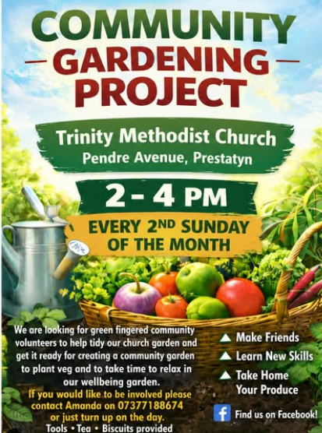
A Message from Amanda, Layworker at Trinity, Prestatyn
Trinity Prestatyn has two exciting projects happening. We have Tea and Toast every Wednesday from 10.30- 12.30 followed by open church inviting the community to come and have a look around the church. Tea and Toast is an opportunity for the church members to connect with the community sharing food and conversation. We also offer surplus food given by local shops to reduce landfill. We have some lovely volunteers but always on the lookout for more helpers.
We are also running a Community Garden Project, where our aim is to tidy up the space, around the church and create a community garden. We aim to have a nature space for insects and hedgehogs and a space where people can plant their vegetables and flowers or just relax in our wellbeing garden.
If these projects are something you would like to get involved in please get in touch.
Layworkeramandab@outlook.com
Know Your Neighbour Talks Tuesday 24 June at 7.00pm
St David’s Methodist Church, Craig-y-Don
We are delighted to welcome Danielle Jacob, a lifelong member of St David’s Church and currently a PhD research student. Danielle will speak about her research into maternity experiences in Ghana and her life as a Christian
Everyone is warmly welcome.
We are also looking for speakers for future “Know Your Neighbour” talks as part of our ongoing programme. If you have a suggestion for a speaker or topic, please let Graham Morgan or one of the hosts know.
The Latest “Churches Together in Britian and Ireland” newsletter is available here
With churches invited to attend online webinars including “Rewilding – Green Christian” Workshop
Green Christian is hosting a Zoom workshop with Wild Card to explore its rewilding campaigns, supporting biodiversity, nature restoration and the abundance of creation. 3rd June 2026
… And information about the “Green Investment Roadshow on 10th June 2026
Operation Noah is inviting you to join them in the inspiring surroundings of Bristol Cathedral to explore how to make your church finances work for climate, nature, and social justice.
More information here
A Message from Liz, Circuit Outreach worker about the Abergele warm space and the Community Choir
We are very thankful the opportunity we have in Abergele.
It has been a blessing to see how the project has grown in the past few months.
When we started in November we had very few numbers but have since increased as word of mouth has got around that we are here to serve our local community.
We now have a regular 15-20 people pop in, either for the full session or just a for a quick brew.
We have had a representative for carers outreach Wales attend (thanks to Maria for the contact), and have a Local historian planned to deliver a talk on his book about the Jewish refugees in Abergele during the second world war, and a talk from a representative from Gwyrch castle.
All members of the community are welcome to join in the community choir that rehearses at St Johns, Llandudno. No need to audition, just come along. Rehearsals are each Monday at 4.00pm.
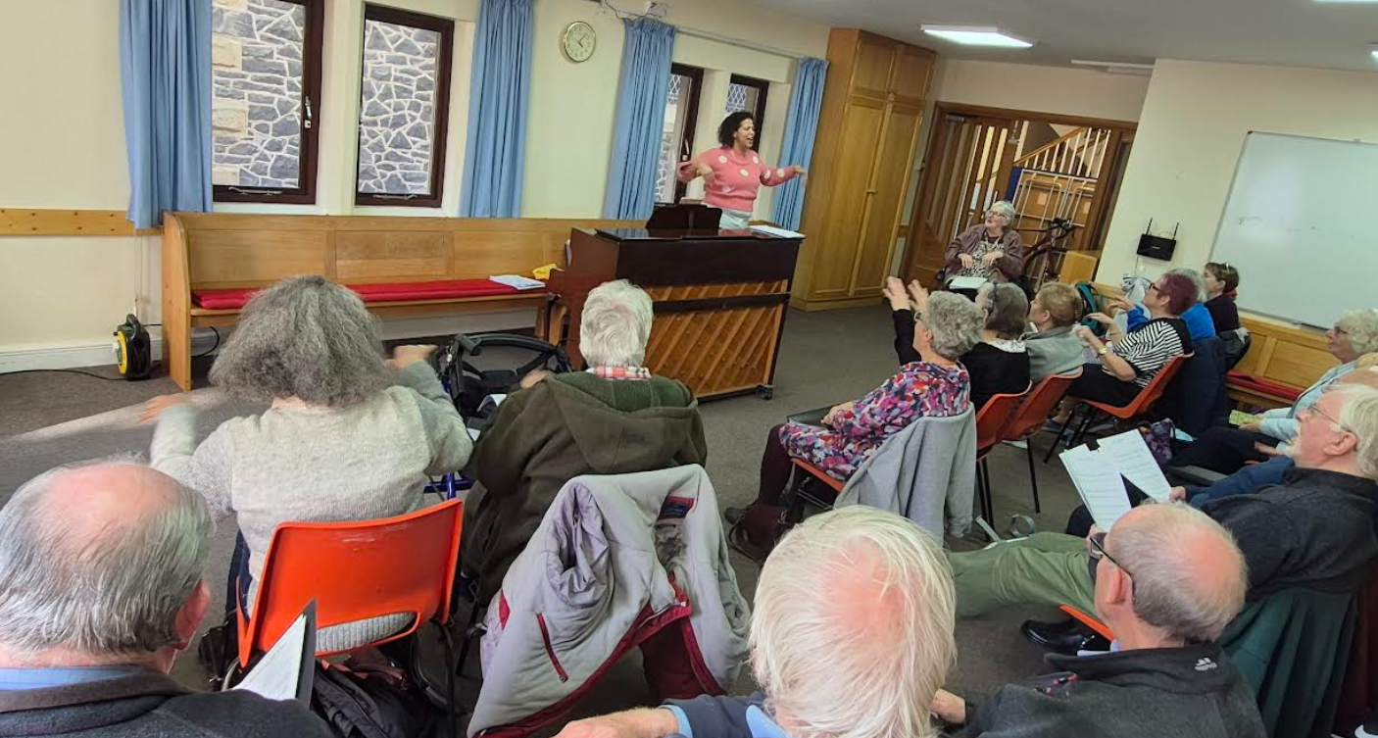

Also, watch this space for a “School Assembly Bangers” sing along! Liz
Circuit Peace and Justice Group
You are warmly invited to join us for the next meeting of the Circuit Peace and Justice Group at 7.00 pm on Monday 16th June at St David's Church, Craig-y-Don.
Our agenda will include:
- Reflecting on the President's and Vice-President's addresses at St John's on 29th May and considering how we might respond to the challenges they presented (see attached report).
- Planning our summer networking picnic on 2nd August.
- Exploring ways to build on the success of our recent Vigil for Peace and encouraging other churches to hold similar events.
The meeting is open to everyone with an interest in peace, justice, and Christian action. Whether you have been involved before or are simply curious to find out more, you will be very welcome.
Please come along and help us continue our Circuit's strong commitment to peace and social justice.
Graham Morgan Convenor
Spotted on a Church noticeboard:

The following were spotted on church noticeboards, newsletters or announced in church services:

“For those who have children and don’t know it, there is a nursery downstairs…”
____________________

“The Rector will preach his final message, after which the choir will sing ‘Break forth into Joy’”
____________________

“Pot Luck Supper on Tuesday at 5.30pm. Prayer and medication to follow”

Dates for your Diary
Taking Care of your Funds for Faith Charities Webinar  Trustee Duties – Webinar – Booking by Bookwhen |  | Thursday 11 June 2026, 12:00pm to 1:00pm
Know your Neighbours Talk  24th June  St Davids, Craig y Don, 7.00 pm |  | A PhD research student. Danielle will speak about her research into maternity experiences in Ghana and her life as a Christian
Farewell Service for Jennie Hurd |  | Saturday 4th July 3pm  St Pauls, Aberystwyth
Adventures in Worship Workshop |  | Saturday 7th November 2026 at St David's Methodist Church, Craig-y-don
USEFUL TO KNOW….
Superintendent | Rev Dr James Garnett  01492596006 |  | james.garnett@methodist.org.uk
Deacon Linda Brown | Deacon Linda Brown  01745 823732 |  | deaconlindabrown@gmail.com
Outreach worker | Liz Royle  07866177832 |  | cpmclayworkerlr@gmail.com
Childrens’ & Families worker | Jodie James  07886177560 |  | cpmclayworkerjj@gmail.com
Circuit Finance Officer | Paula Hammond  01492878447 |  | cpmfinance2021@gmail.com
Circuit Administrator / Safeguarding | Hayley J. Allport  014920860439 |  | cpmcoffice2@gmail.com

