PEACE VIGIL
SATURDAY 3 February 2-4PM
IN NORTH WESTERN GARDENS, MOSTYN STREET.

Join us in a call for peace and a ceasefire in Gaza, Israel and the West Bank.

This will be a silent vigil. We shall not be engaged in chanting, singing, or conversation.
We have suitably worded placards available for you to hold in your silent call for peace.
Everyone is welcome to join us, even if only for just a few minutes.

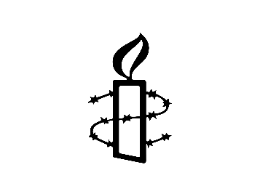
Organised by Colwyn Bay Group of Amnesty International

