
Circuit News

For members of our circuit and friends, please find the latest circuit news......
Remember that not everyone has access to the internet. Perhaps there are visitors to your church who may not be on our circulation list...
Please feel free to print out a few copies to spread the news!
Some churches have also included a link in their own newsletter which allows people to click to access the bulletin directly! Great idea!
A Message from Jodie, Childrens’ & Families Worker
Great News!
I have been meeting with a small group of young people on a circuit at The Garage!
Can YOU help?
Can you spare an hour and a half on a Wednesday evening to join us? You don’t need to commit to every week, or even every other - just let me know the date(s) you are available, and I can add your name to the rota!
Even if it’s just once! Any help is appreciated! Want more info? – Let me know and we can chat!
Know a young person who’d like to join us? Brilliant! Let me know!

Please pray for our group! Thank you
Jodie 07886 177560

A message from Christian Aid - What has happened?

The 6.1 magnitude earthquake that struck eastern and rural Afghanistan - and shook buildings from Kabul to Pakistan's capital Islamabad - has killed more than 800 people.

Colleagues and partners tell us that people have been severely impacted by the earthquake, causing both human casualties and significant financial losses to local communities. We have been told homes made of mud and wood collapsed as helicopters were sent in to evacuate the injured.

Afghanistan is one of the worlds’ poorest countries, with nearly half the population needing humanitarian assistance before the earthquake due to conflict, drought, displacement, and political turmoil. In 2025, almost half of the population – some 22.9 million people – already required humanitarian assistance to survive.

Life-saving rescue operations are needed to save the masses trapped under the rubble. Many more are in need of drinking water, food, shelter, blankets and cooking sets, and critical medical supplies.

What we are doing:

Our partners have already reached some of the affected areas. Christian Aid is working closely with our networks to carry out assessments and to identify the extent of the damage and the risk to the most vulnerable, especially for women and girls. The remoteness of the areas hit by the quake makes the search and rescue even harder.

Our partner OCHR (Organisation for Coordination of Humanitarian Relief) maintains a strong operational presence in the affected eastern provinces and ensures aid is locally led and community-focused.

Christian Aid has released an initial £50,000 to OCHR which will aid an emergency humanitarian response consisting of food parcels, water kits, shelters, and cash for essential supplies.

We are ready to stand by our partners and quake-affected communities to support their recovery over the coming weeks and months.

More on Christian Aid's response and how to help: Afghanistan Earthquake Appeal - Christian Aid

Mari McNeill, Pennaeth Cymorth Cristnogol Cymru / Head of Christian Aid Wales

A Message from Liz Royle, Circuit Outreach Worker
Circuit Harvest Service
We are hoping to assemble together again for our Harvest circuit service.
It would be great to have a band similar to what we had for the June songs of Praise.
The service is on Sunday 14th September, 6:30pm at St John's Llandudno.
We will again meet just before the service to practice together at St Johns 4:45pm for a 5pm start. Noting that we will need to set up etc before the practice.
Please let me know if you wish and are able to participate this time round.
Thanks
Liz

Cuddly Toys Take the Leap of Faith at St John’s Zip Wire!
In a daring display of bravery (and stuffing), Sarah from St John’s teamed up with her trusty teddy bears to tell the tale of their high-flying adventures on the Zip Line. Rumour has it some bears required a quick medical check-up before take-off, while others demanded extra honey as danger money.
If you’d like to read the full story of their fearless flight, you can catch all the thrills, spills, and slightly wobbly landings in Sarah’s account of the day.
please click here.

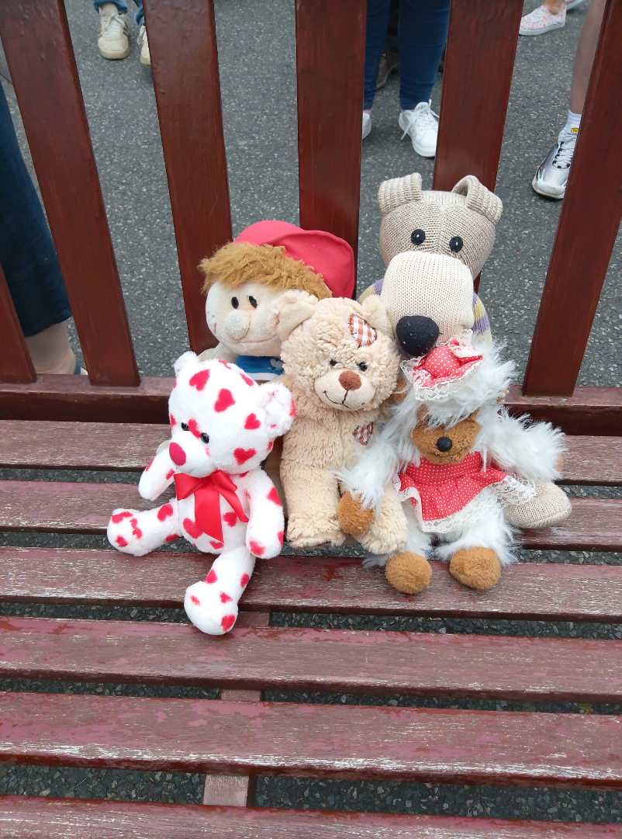
Odd Socks, Davy, Kathy, Molly and Valentine when they had completed the zipwire challenge

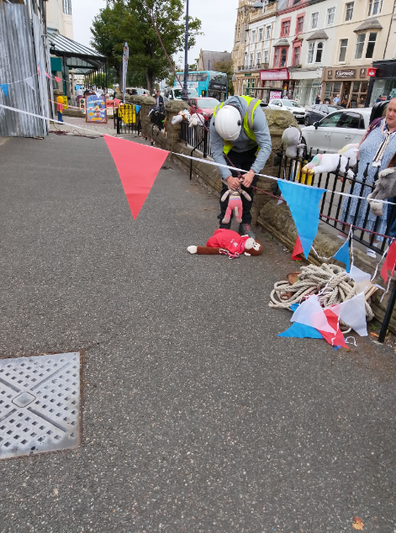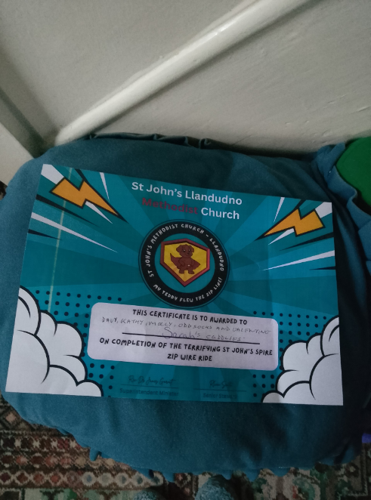

Kathy Bear had just made her descent.

An Invitation from Linking Lives Cymru - online drop-in
I wanted to invite you to an online, informal conversation to learn more about the work of Befriending Networks and Linking Lives UK in Wales and meet and swap notes with other churches and organisations interested in befriending or working more broadly to address chronic loneliness and social isolation.
I'll be hosting this drop-in on zoom, on Tuesday 16th September, 11.30am - 12.15pm. The details for joining are below. Whether you can drop in for ten minutes, or for the whole thing, it would be great to see you there! If you have any questions, or can't make it to this drop-in but want to arrange a 1:1 conversation (even if we've already connected), please do reach out!
- Befriending Networks is inviting you to a scheduled Zoom meeting.
Join Zoom Meeting
https://us02web.zoom.us/j/82633548244?pwd=oHnSzFpeGPSCyP4mL0wcomodX0AuNt.1
Meeting ID: 826 3354 8244 Passcode: 995669
Cofion Cynnes / Kind regards, Matt


The Big Church Read

The Greatest Story Ever Told, with Bear Grylls, is joining the Big Church Read this October! The first video goes live on 15 October, followed by a new release every Wednesday for five weeks. All videos will stay online—so your group can join in or catch up anytime.
Over 100,000 people across 1,000 churches are expected to join in. Get your copy of the book, and maybe some more to give away, with our bulk discount offers available now!

Watch Bear's Intro Video

This is Just the Start...
Our dream is that the Big Church Read will encourage those 100,000 readers in October to give away 10 copies to their friends and neighbours at Christmas, to get 1 million copies of His Word into the hands of the nation.
Register Your Interest at the Big Church Read to stay up to date on everything "The Greatest Story Ever Told" is doing this year!

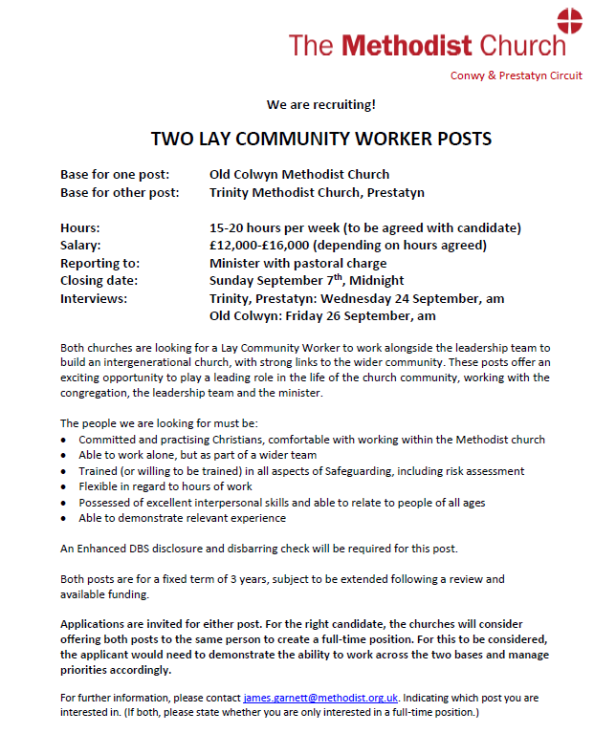
DATES FOR YOUR DIARY

“Incredible Edible” at Old Colwyn Church

You don’t need to know anything about gardening to join in; just a willingness to get involved and eat cake!
Rake & Cake |  |  |  | 20th September |  | 10 – 12pm
Know Your Neighbour Talk |  |  |  | Wednesday  September 24th 7pm St David's Church |  | Jonathan Williams will take us on a tour of the criminal underworld with a focus on busting fraud and investigating crime.  “Watch out there is a thief about”
Thursday 4th September |  |  | WALKING/STROLLING GROUP  Meet at 10am at St David’s, Craig y Don |  |  |  | Contact: martin.snellgrove@hotmail.com email. 07853 150826 text
Sunday 14 September 2025 |  |  | Deadline for articles for the Autumn Circuit Magazine |  |  |  | Please contact Maria at St Davids for more information maria.s.carter7@gmail.com
Sunday 7 December 2025 |  |  | Deadline for articles for the Winter Circuit Magazine
REGULAR EVENTS

Monday | Toddlers Sing and play |  |  |  |  |  |  | St Johns, Llandudno  09:45am -10:45am
 | Circuit Choir |  |  |  |  |  |  | St Davids, Craig y Don  4.00 - 5.00 pm
 | Hand Bell Ringers Practice  open to anyone |  |  |  |  |  |  | St Johns, Llandudno  12.30pm to 2pm
Tuesday | Coffee and reflection |  |  |  |  |  |  | St John's, Conwy  10.00 -12.00pm
 | Circuit Prayer Gathering |  |  |  |  |  |  | Llanddulas  10.30am
 | Circuit Prayer Gathering |  |  |  |  |  |  | Conwy  11.45am
 | Open House |  |  |  |  |  |  | St Davids Craig y Don  11am to 2pm
Wednesday | Coffee morning and reflection |  |  |  |  |  |  | St David's, Craig y Don  10.00am – 12.00pm
 | “Butterflies” Toddlers |  |  |  |  |  |  | St John's Conwy  9.30am-11.00am
Thursday | Circuit Prayer Gathering |  |  |  |  |  |  | Old Colwyn  10.30am
 | Prayers for Healing & Wholeness  (If you have any prayer requests, please bring on the day) |  |  |  |  |  |  | St John's, Llandudno  1:45pm-2:15pm
Friday | Circuit Prayer Gathering |  |  |  |  |  |  | St Johns, Llandudno  9.30am
 | Community Cafe |  |  |  |  |  |  | St Johns, Llandudno  10am-12pm
 | Trinity Toddlers |  |  |  |  |  |  | Trinity, Prestatyn  9.30am-11.00am
 | Toddlers Group |  |  |  |  |  |  | St Davids, Craig y Don  9.00am-11.00am
 | Warm welcome |  |  |  |  |  |  | St Johns, Llandudno  1.00pm – 4.00pm
USEFUL TO KNOW….
Superintendent |  | Rev Dr James Garnett  01492596006 |  |  | james.garnett@methodist.org.uk
Deacon Linda Brown |  | Deacon Linda Brown  01745 823732 |  |  | deaconlindabrown@gmail.com
Outreach worker |  | Liz Royle  07866177832 |  |  | cpmclayworkerlr@gmail.com
Childrens’ & Families worker |  | Jodie James  07886177560 |  |  | cpmclayworkerjj@gmail.com
Circuit Finance Officer |  | Paula Hammond  01492878447 |  |  | cpmfinance2021@gmail.com
Circuit Administrator / Safeguarding |  | Hayley J. Allport  014920860439 |  |  | cpmcoffice2@gmail.com

Podcasts, Websites, Newsletters & Publications that may be of interest..

The Methodist Church | Click here to visit.
Our Circuit website | Click here to Visit
Methodist Property Matters | Click here to Visit
CTBI - Churches together in Britain and Ireland  Serving the churches of Britain and Ireland on the shared journey towards full visible unity in Christ. | Click here to visit.
All We Can - An international relief and development movement, rooted in the Christian faith. Together, we're finding solutions to poverty. | Click to visit
Cytûn - Churches together in Wales website | Click here to visit
The Well - For children, youth, schools and family workers | Click here to visit
JPIT - Joint Public Issues Team (Churches working for Peace and Justice) | Click here to visit
Fund for Human need | Click here to visit
Methodist Women in Britain | Click here to visit

