For members of our circuit and friends, please find the latest circuit news......
Remember that not everyone has access to the internet. Perhaps there are visitors to your church who may not be on our circulation list...
Please feel free to print out a few copies to spread the news!
Some churches have also included a link in their own newsletter which allows people to click to access the bulletin directly! Great idea!

Changemakers

We would like to put a group together of circuit volunteers who would be interested in this:
A new project at Conwy Mind called ‘Changemakers’, funded by the National Lottery, aims to ‘recruit’ and support mental health champions across Conwy.
‘Changemakers’ will be offering free workshops which will be designed to give people the confidence to talk about mental health and to challenge stigma.

There is some more information about the project on the website if you would like more detail:

https://www.conwymind.org.uk/get-involved/mental-health-changemakers-changing-minds/

If you would be interested in joining a circuit team to take part please contact Hayley at the circuit office.

Circuit Praise

We are looking for volunteer musicians for the circuit praise evening on 8th June, 6:30pm.
We hope to assemble a band of people together to play. If you are interested please let Liz (Outreach worker know) Email in the plan.
Easter Offering

Thank you everyone who gave so generously to the Easter Offering Appeal that raised the magnificent sum of £1006.61 for the Methodist Church World Mission Fund. Last year we raised £798.74 so thank you for the extra! With the needs in our world, all contributions were gratefully received. Although organised by Methodist Women in Britain (MWiB) all monies raised went to the World Mission Fund. Thank you to everyone who took part in the Circuit Service, readers, musicians, choir and congregation and to St John’s Conwy for their hospitality.

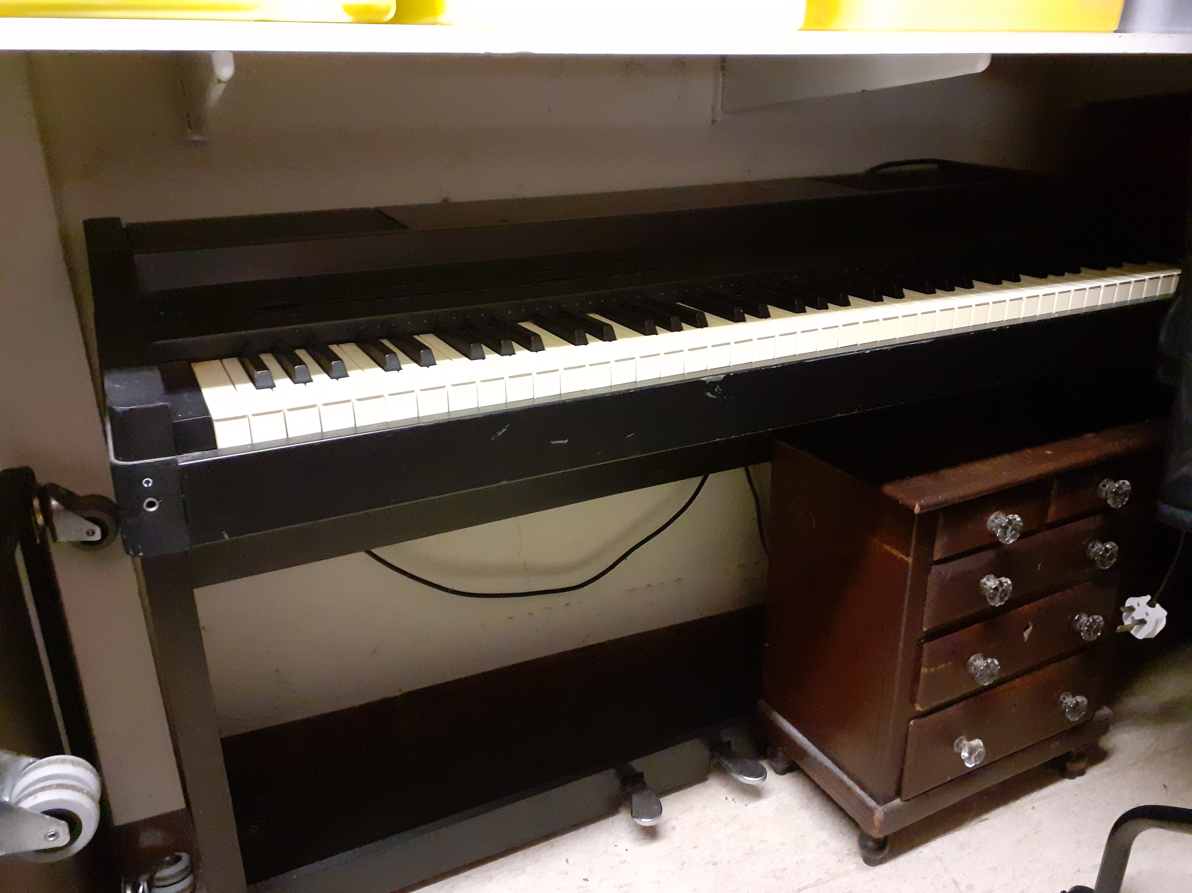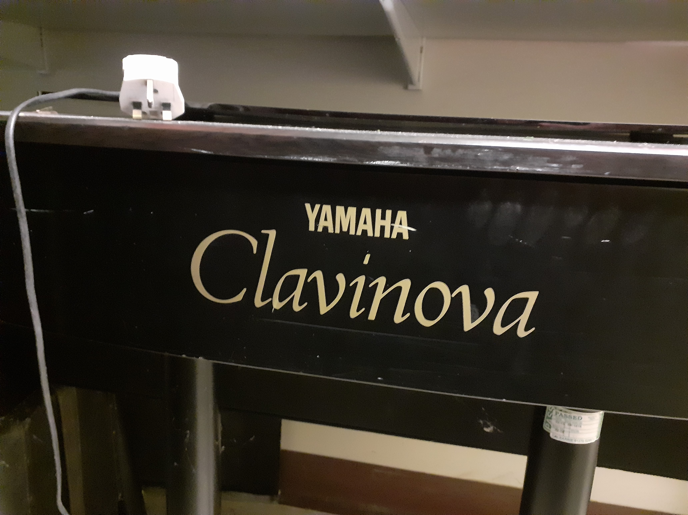

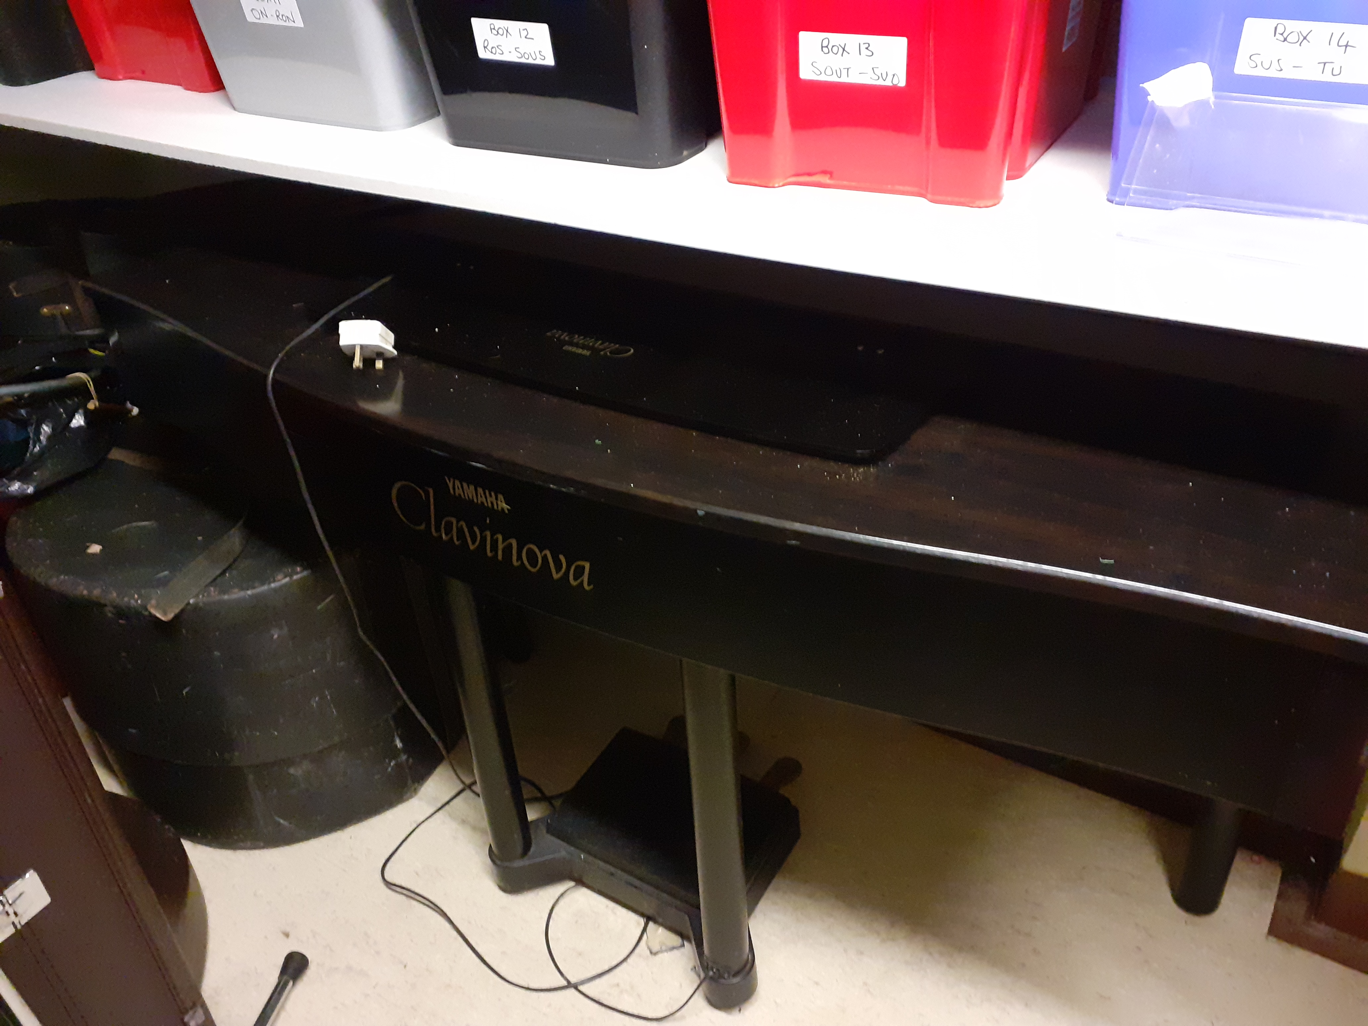

Clavinova Digital piano available
Please contact Vic Htchings at Old Colwyn for more details.

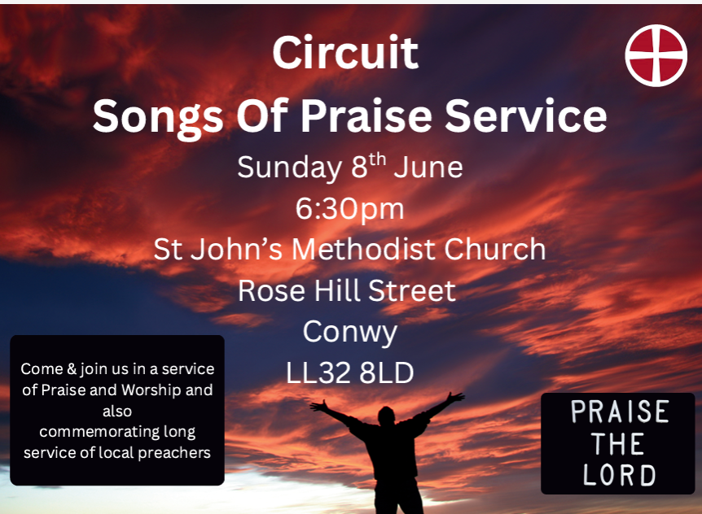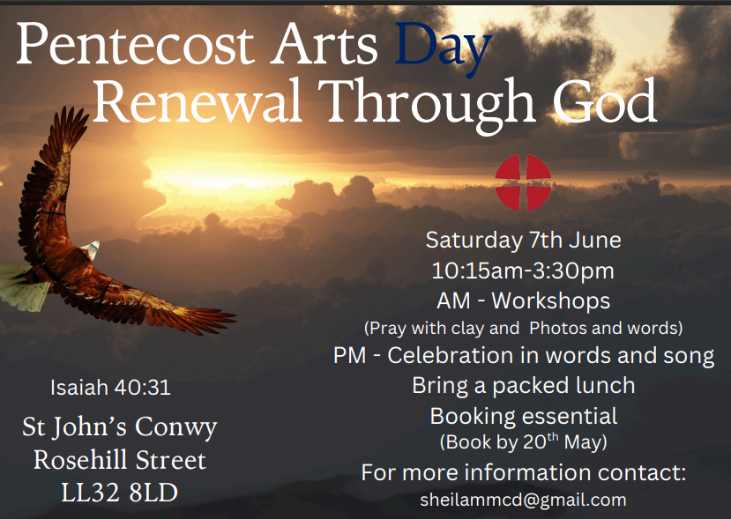
BIBLE MONTH: THE GOSPEL OF JOHN

You are very welcome to join this year’s Circuit Bible Studies, which will focus on the Gospel of John.

These will be at St David’s Church, Craig-y-Don on Monday evenings from
7.30 to 9.00 p.m. on the following dates:
Session 1: June 30th Session 2: July 7th Session 3: July 14th Session 4: July 21st
(Another venue in the Circuit may also be arranged.)
David Lamb will lead the sessions. He will give a short introduction to each session. We will then split into small groups to study particular sections of the Gospel, using simple-to-follow booklets. We will also be encouraged to read through the whole of the Gospel of John for ourselves at home, using a 30-Day Reading Guide.
If you would like to join in, could you please let David know by email or phone, so that he can make sure that there are enough booklets for everybody. Email: david.a.lamb@btinternet.com Phone: 01492 549111

DATES FOR YOUR DIARY

Friday May 30th  1 – 5 pm  Old Colwyn |  | Xplore Science Discovery Centre  Free Community Event |  | Contact Jodie James for more information
Assemble at 10am at St David’s, Craig y Don on |  | Walking Group  The walk will be almost level, on the road near and alongside the lake called Llyn Syberi to the south of Tal y Cafn on the A470. Being about 600 feet above sea level there will be good views, however our cars will do the hard work of getting us up there! The total distance to walk will be less than 2 miles. |  | Contact maria Carter at St Davids for more information
Sunday 8th June at St John’s Conwy at 6.30pm. |  | Songs of Praise:  Renewal Through God |  | We invite you to contribute by way of hymn + testimony Please let Hayley or James know whether you would like to request a hymn, and a few sentences explaining why you have chosen it.
St Johns Conwy  Saturday 7th June 1-3.30pm |  | Pentecost Arts Day |  | Refer to Bulletin April 10th for more information or Contact sheilammcd@gmail.com
7th -15th June |  | Churches Count on Nature Week |  | Use this Link to find out more: Churches Count on Nature 2025 (Refer to Bulletin April 10th for more information)
Saturday July 19th at Llanddulas 9.30am |  | Circuit Prayer Breakfast |  | Please contact Deacon Linda Brown or the circuit office for more information.
REGULAR EVENTS

Monday |  | Toddlers Sing and play |  | St Johns, Llandudno  09:45am -10:45am
 |  | Circuit Choir |  | St Davids, Craig y Don  4.00 - 5.00 pm
 |  | Hand Bell Ringers Practice  open to anyone |  | St Johns, Llandudno  12.30pm to 2pm
Tuesday |  | Coffee and reflection |  | St John's, Conwy  10.00 -12.00pm
 |  | Circuit Prayer Gathering |  | Llanddulas  10.30am
 |  | Circuit Prayer Gathering |  | Conwy  11.45am
 |  | Open House |  | St Davids Craig y Don  11am to 2pm
Wednesday |  | Coffee morning and reflection |  | St David's, Craig y Don  10.00am – 12.00pm
 |  | “Butterflies” Toddlers |  | St John's Conwy  9.30am-11.00am
Thursday |  | Circuit Prayer Gathering |  | Old Colwyn  10.30am
 |  | Prayers for Healing & Wholeness  (If you have any prayer requests please bring on the day) |  | St John's, Llandudno  1:45pm-2:15pm
Friday |  | Circuit Prayer Gathering |  | St Johns, Llandudno  9.30am
 |  | Community Cafe |  | St Johns, Llandudno  10am-12pm
 |  | Trinity Toddlers |  | Trinity, Prestatyn  9.30am-11.00am
 |  | Toddlers Group |  | St Davids, Craig y Don  9.00am-11.00am
 |  | Warm welcome |  | St Johns, Llandudno  1.00pm – 4.00pm
USEFUL TO KNOW….
Superintendent | Rev Dr James Garnett  01492596006 |  | james.garnett@methodist.org.uk
Deacon Linda Brown | Deacon Linda Brown  01745 823732 |  | deaconlindabrown@gmail.com
Outreach worker | Liz Royle  07866177832 |  | cpmclayworkerlr@gmail.com
Childrens’ & Families worker | Jodie James  07886177560 |  | cpmclayworkerjj@gmail.com
Circuit Finance Office | Paula Hammond  01492878447 |  | cpmfinance2021@gmail.com
Circuit Administrator / Safeguarding | Hayley J. Allport  014920860439 |  | cpmcoffice2@gmail.com

Podcasts, Websites, Newsletters & Publications that may be of interest..

The Methodist Church | Click here to visit.
Our Circuit website | Click here to Visit
Methodist Property Matters | Click here to Visit
CTBI - Churches together in Britain and Ireland  Serving the churches of Britain and Ireland on the shared journey towards full visible unity in Christ. | Click here to visit.
All We Can - An international relief and development movement, rooted in the Christian faith. Together, we're finding solutions to poverty. | Click to visit
Cytûn - Churches together in Wales website | Click here to visit
The Well - For children, youth, schools and family workers | Click here to visit
JPIT - Joint Public Issues Team (Churches working for Peace and Justice) | Click here to visit

