For members of our circuit and friends, please find the latest circuit news......
Remember that not everyone has access to the internet. Perhaps there are visitors to your church who may not be on our circulation list...
Please feel free to print out a few copies to spread the news!
Some churches have also included a link in their own newsletter which allows people to click to access the bulletin directly! Great idea!

The latest Cytun Policy Bulletin is available here and on our circuit website.

Policy Bulletin April May 2025 (1).pdf

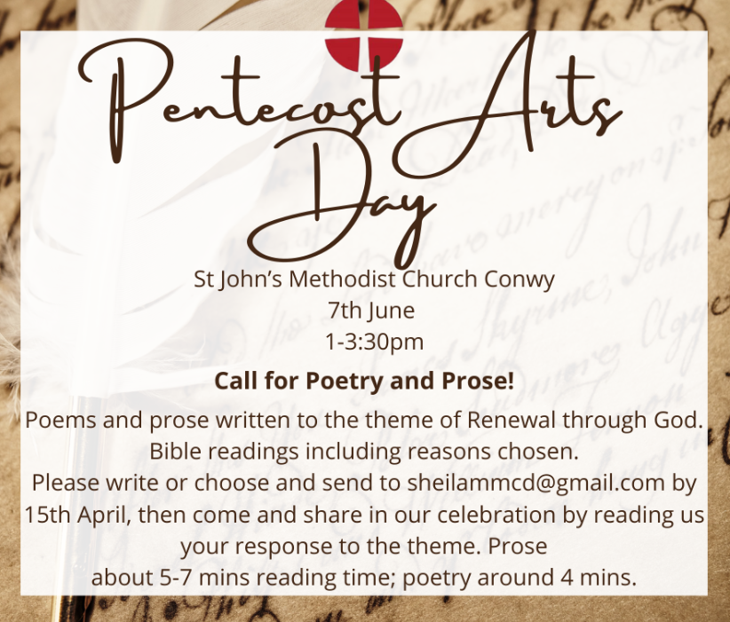

Eva Daniels
We were saddened to hear of the passing of Eva Daniels who died peacefully the evening of Saturday March 15th. She was a Local Preacher and had been involved with the Healing and Wholeness Ministry at St John's, Llandudno, in the past. She had had poor health for some time.
Eva's niece Janet is planning- for her farewell..tea, perhaps in a nearby hotel, to follow a memorial service at St John's 1.15pm Wednesday April 9th, after a private cremation.
If you are planning to come to the tea please will you let Lyn in St John's Office know so that numbers can be given to Janet.
Please remember Eva and her family and friends in your prayers.

Spoof Emails
We've heard from a couple of people that they have had spoof emails that look to be from Rev Garnett, asking them to run an errand. Please do not to respond to any email that you may be suspicious of. If you aren't sure, you can click on Rev Garnett's name at the top of the email and check the address.

Walking Group
The Walking Group will next meet on Monday 7th April at 10am at St David's.
Members are asked to bring their cars to make sure that there are enough spaces for people without. The walk itself will begin at the car park near the community centre in Rowen, LL32 8YA , four miles south of Conwy, about 10:30am.
It will involve walking up through this pretty village and back, taking in small diversions of interest, including the chapel. The length will be two miles which might take an hour. The only part of the walk which will not be accessible to those in wheelchairs or on scooters would be the foot bridges over the river just off the main route. There are neither toilets nor cafes in the village.
On our way home we may stop at Pontwgan to look at the bridge, which is built above a waterfall.
The walk will be led by Martin Snellgrove.

The Chosen
Cineworld, Llandudno Junction will be showing, The Chosen : The Last Supper for four showings only from Thursday, 10th April through to Sunday, 13th. Check their website for further details.

Free to a good home..
Desk and two three-drawer units

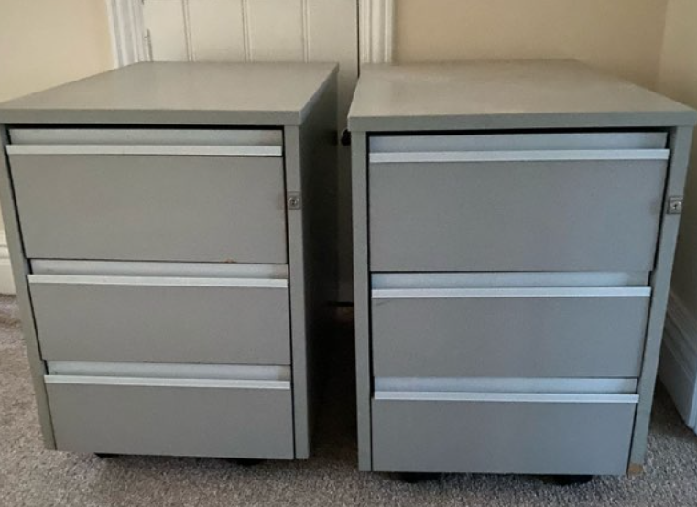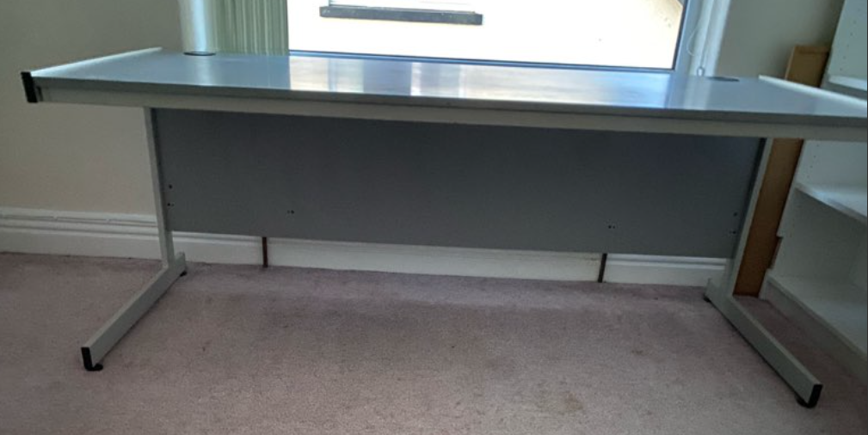
Open House

St David’s Church, Craig-y-Don, opens its doors every Tuesday to welcome everyone in the community.
From 11am to 2pm, it offers a warm, sociable space that’s becoming a much-loved fixture in the local social scene. With attendance steadily growing, visitors enjoy delicious refreshments—including homemade soup, cakes, biscuits, and tea or coffee—prepared in the church’s spotless, highly rated kitchen. There is no charge but some people choose to leave a donation .
Guests are free to mingle, chat, and connect with a diverse mix of people. Some come because they live nearby, others out of curiosity, or simply in search of companionship and a warm welcome. Whether you’re keen to join in a jigsaw puzzle, play a game, borrow a book, or just enjoy a good conversation, there’s something for everyone.

DATES FOR YOUR DIARY

Wednesday evenings,  8-9pm  The first session will be on Wednesday 12th March, and the last on Wednesday 16th April. |  | Circuit Lent Bible Study: Growth in Christ  These studies will set the weekly Gospel readings alongside our continuing journey with Elijah this year.  Join for one or for the whole series |  | Zoom Link: Meeting ID: 849 6735 1356  Passcode: 210095 https://us02web.zoom.us/j/84967351356?pwd=NUgaH2eFa7kV1b2oJ5P68sqEJEra6u.1
Tuesday 7th April 7pm  St Paul’s Church, Colwyn Bay |  | “Waves of Hope”  A concert of spectacular music for Water aid  £10 admission on the door, children free |  | Please contact Ardal Cenhadaeth Aled Mission Area for more details
30th March – 5th April at Beechwood Court, Conwy |  | Music Week with Roger Jones  Spend the week enjoying great teaching, fellowship and music with the opportunity to perform or watch the performance of “ZAC” at the Presbyterian Church, Penrhyn Bay on Friday 4th April at 7pm |  | For more information contact events8@cmm.org.uk
Tuesday, 6th May - Friday, 9th May. |  | Keswick Bible Week  ‘The Sensational Newness of the Good News’ |  | Contact Carol Reynolds, on behalf of the Bible Week organising committee
REGULAR EVENTS

Monday |  | Toddlers Sing and play |  | St Johns, Llandudno  09:45am -10:45am
 |  | Circuit Choir |  | St Davids, Craig y Don  4.00 - 5.00 pm
 |  | Hand Bell Ringers Practice  open to anyone |  | St Johns, Llandudno  12.30pm to 2pm
Tuesday |  | Coffee and reflection |  | St John's, Conwy  10.00 -12.00pm
 |  | Circuit Prayer Gathering |  | Llanddulas  10.30am
 |  | Circuit Prayer Gathering |  | Conwy  11.45am
 |  | Open House |  | St Davids Craig y Don  11am to 2pm
Wednesday |  | Coffee morning and reflection |  | St David's, Craig y Don  10.00am – 12.00pm
 |  | “Butterflies” Toddlers |  | St John's Conwy  9.30am-11.00am
Thursday |  | Circuit Prayer Gathering |  | Old Colwyn  10.30am
 |  | Prayers for Healing & Wholeness  (If you have any prayer requests please bring on the day or send them to eldensmall376@gmail.com) |  | St John's, Llandudno  1:45pm-2:15pm
Friday |  | Circuit Prayer Gathering |  | St Johns, Llandudno  9.30am
 |  | Community Cafe |  | St Johns, Llandudno  10am-12pm
 |  | Trinity Toddlers |  | Trinity, Prestatyn  9.30am-11.00am
 |  | Toddlers Group |  | St Davids, Craig y Don  9.00am-11.00am
 |  | Warm welcome |  | St Johns, Llandudno  1.00pm – 4.00pm
USEFUL TO KNOW….
Superintendent | Rev Dr James Garnett  01492596006 |  | james.garnett@methodist.org.uk
Deacon Linda Brown | Deacon Linda Brown  01745 823732 |  | deaconlindabrown@gmail.com
Outreach worker: | Liz Royle  07866177832 |  | cpmclayworkerlr@gmail.com
Childrens’ & Families worker | Jodie James  07886177560 |  | cpmclayworkerjj@gmail.com
Circuit Finance Office | Paula Hammond  01492878447 |  | cpmfinance2021@gmail.com
Circuit Administrator / Safeguarding | Hayley J. Allport  014920860439 |  | cpmcoffice2@gmail.com
A Message from Meaningful Chocolate Company
We invite you to take part in this year’s Real Easter Egg campaign.
In 2010 churches helped found The Meaningful Chocolate Company by placing orders for the first Real Easter Eggs.
We still rely on our supporters to encourage people to buy a Real Easter Egg for family and friends as a simple way of sharing the Good News. The Real Easter Egg is the only Fairtrade egg which includes a 24 page copy of the Easter story in each box and which supports charitable projects.
How you can help
Last year hundreds of churches placed orders directly with us in quantities ranging from 12-1,000 eggs. For the past 15 years, we have relied on people being champions by buying direct from us, spreading the word and encouraging others to buy. Direct sales are very important for our company to trade. This year we are offering four ways to buy from us:
- Be a Champion and collect orders from family and friends and order a case from us
- Buy a case to share with friends, family or a school
- Send single eggs in any numbers direct through the post
- Sponsor an egg, case or pallet to be sent to a food bank
A gift for individuals and groups
This year there are five types of Eggs designed as personal gifts and there is also our sharing box designed for larger events or for giveaways or goody bags. Each egg has a new edition of the Easter story in the box. The Original, Dark, Mugs and Fun Packs are designed to be a personal gift for people of all ages. For people looking to buy for Children’s Easter events, Messy Church or for outreach giveaways, we have our Sharing Boxes.
Real Easter Egg Competition.
Inside each of our Easter story books there is a chance to win £200 worth of book tokens. The story books come free with our Original, and Dark eggs. The competition is open to all young people. There are two categories: Junior and Senior. All the entrant has to do is answer some general knowledge questions about Easter which are at the back of the book.
There is a first prize of £50 in book tokens in each category and two runner up prizes of £25 worth of tokens in each category. All entries with correct answers will be entered into the prize draw.
Entries need to be with us by 6th May 2025 Details here.


Podcasts, Websites, Newsletters & Publications that may be of interest..
The Methodist Church | Click here to visit.
Our Circuit website | Click here to Visit
Methodist Property Matters | Click here to Visit
CTBI - Churches together in Britain and Ireland  Serving the churches of Britain and Ireland on the shared journey towards full visible unity in Christ. | Click here to visit.
All We Can - An international relief and development movement, rooted in the Christian faith. Together, we're finding solutions to poverty. | Click to visit
Cytûn - Churches together in Wales website | Click here to visit
The Well - For children, youth, schools and family workers | Click here to visit
JPIT - Joint Public Issues Team (Churches working for Peace and Justice) | Click here to visit

