For members of our circuit and friends, please find the latest circuit news......
Remember that not everyone has access to the internet. Perhaps there are visitors to your church who may not be on our circulation list...
Please feel free to print out a few copies to spread the news!
Some churches have also included a link in their own newsletter which allows people to click to access the bulletin directly! Great idea!
The National Churches Survey: giving every church a voice

The Methodist Church is currently underrepresented and thus the NCT has extended the deadline to Sunday the 13th of July.

The National Churches Trust is carrying out a survey to help policymakers, the media, and the wider public better understand the challenges churches face and to highlight the vital work that churches, like yours, do.
This survey has the support of denominations, faith, and heritage groups across the country and we encourage you to take part.
Your response will provide essential evidence to build a clearer picture – to tell a stronger, more informed story about your church, and others like it, so that together we can address some of the biggest challenges facing churches and help ensure their future.
Please complete The National Churches Survey and encourage others you know to join in too. The more churches that take part, the more impactful it will be.
[Version in English] Take part in the survey and find out more information at nationalchurchestrust.org/survey
[Version in Welsh] https://www.nationalchurchestrust.org/arolwg

A Message from Rev Dr. Jennie Hurd

Dear Friends
I am writing to invite you to an Afternoon Tea to express our thanks to Mrs Delyth Wyn Davies as she retires as a member of the Learning Network Team with us here in Wales at the end of August. Delyth has served us faithfully since 2014 and we owe her a great deal.
The Tea will be held on Tuesday 8th July between 3.00-4.30pm at the Sweeney Hall Hotel, Morda, Oswestry SY10 9EU (right by the A483). The date and location have been chosen in order to fit in with Delyth’s busy diary.
All are welcome - please do share this invitation - but I need to know who is coming by the evening of Wednesday 3rd July, please, so that I can complete the booking with the hotel.
I hope a good number of us will be able to come together to thank Delyth and to wish her well for the future.
Every blessing to you,
Jennie

Please remember that the cut off date for planning for the next quarter is Friday July 4th.
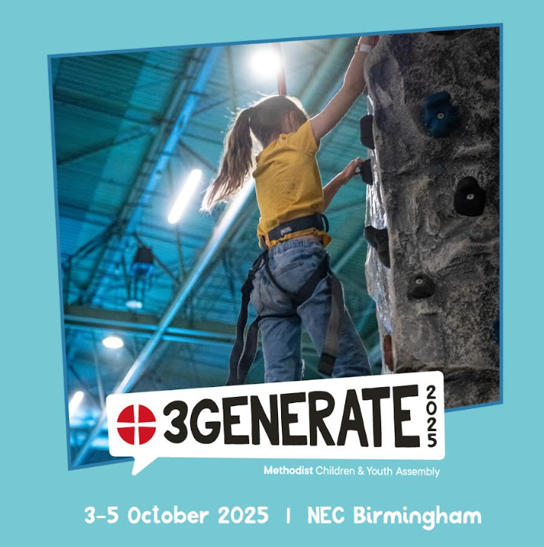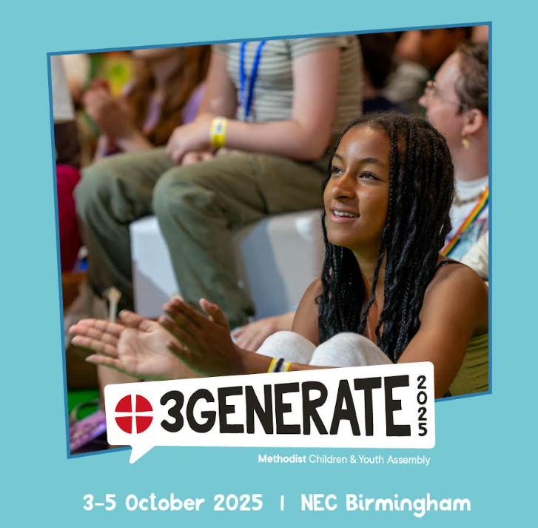
Donate Your Unwanted Lego!
Got old Lego gathering dust?
Help us bring creativity and joy to more children—donate your unwanted Lego today!
Every brick makes a difference. Drop off your Lego with Liz Outreach worker at St John’s- Llandudno and give it a new life in the hands of young builders.
Email Liz to arrange drop off- cpmclayworkerlr@gmail.com

Suicide Awareness

The Connexional Safeguarding Team is organising a webinar on the theme of Suicide Awareness on Tues 15 July, 11am - 12.30pm.

Organised by the Connexional Safeguarding Team, this 90 minute webinar will be facilitated by David Brown, Head of Training and Development at If U Care Share foundation, a suicide prevention charity based in the North East of England.
The webinar will cover:
An introduction to suicide prevalence / Language around suicide / Impact of suicide / Available support

Please sign up for the webinar here:
www.methodist.org.uk/safeguarding/webinars/suicide-awareness-webinar-tuesday-15-july-2025/

DATES FOR YOUR DIARY

Circuit Bible Study which will focus on the Gospel of John.  St David’s Church, Craig-y-Don  7.30 to 9.00 p.m |  | Circuit Bible Study  Bible Month: The Gospel of John |  | If you would like to join in, could you please let David Lamb know by email or phone, so that he can make sure that there are enough booklets for everybody.  Email: david.a.lamb@btinternet.com Phone: 01492 549111
 |  | Session 1: June 30th
 |  | Session 2: July 7th
 |  | Session 3: July 14th
 |  | Session 4: July 21st
29th June @ St John's Old Colwyn 6pm |  | Old Colwyn Churches Together  Praise evening |  | Please contact the circuit office or Liz Royle, Outreach worker for more information
Tues 15 July, 11am - 12.30pm |  | Suicide Awareness webinar (online) |  | Sign up here for the webinar.
Saturday July 19th at Llanddulas 9.30am |  | Circuit Prayer Breakfast |  | Please contact Deacon Linda Brown or the circuit office for more information.
REGULAR EVENTS

Monday |  | Toddlers Sing and play |  | St Johns, Llandudno  09:45am -10:45am
 |  | Circuit Choir |  | St Davids, Craig y Don  4.00 - 5.00 pm
 |  | Hand Bell Ringers Practice  open to anyone |  | St Johns, Llandudno  12.30pm to 2pm
Tuesday |  | Coffee and reflection |  | St John's, Conwy  10.00 -12.00pm
 |  | Circuit Prayer Gathering |  | Llanddulas  10.30am
 |  | Circuit Prayer Gathering |  | Conwy  11.45am
 |  | Open House |  | St Davids Craig y Don  11am to 2pm
Wednesday |  | Coffee morning and reflection |  | St David's, Craig y Don  10.00am – 12.00pm
 |  | “Butterflies” Toddlers |  | St John's Conwy  9.30am-11.00am
Thursday |  | Circuit Prayer Gathering |  | Old Colwyn  10.30am
 |  | Prayers for Healing & Wholeness  (If you have any prayer requests please bring on the day) |  | St John's, Llandudno  1:45pm-2:15pm
Friday |  | Circuit Prayer Gathering |  | St Johns, Llandudno  9.30am
 |  | Community Cafe |  | St Johns, Llandudno  10am-12pm
 |  | Trinity Toddlers |  | Trinity, Prestatyn  9.30am-11.00am
 |  | Toddlers Group |  | St Davids, Craig y Don  9.00am-11.00am
 |  | Warm welcome |  | St Johns, Llandudno  1.00pm – 4.00pm
USEFUL TO KNOW….
Superintendent | Rev Dr James Garnett  01492596006 |  | james.garnett@methodist.org.uk
Deacon Linda Brown | Deacon Linda Brown  01745 823732 |  | deaconlindabrown@gmail.com
Outreach worker | Liz Royle  07866177832 |  | cpmclayworkerlr@gmail.com
Childrens’ & Families worker | Jodie James  07886177560 |  | cpmclayworkerjj@gmail.com
Circuit Finance Office | Paula Hammond  01492878447 |  | cpmfinance2021@gmail.com
Circuit Administrator / Safeguarding | Hayley J. Allport  014920860439 |  | cpmcoffice2@gmail.com

Podcasts, Websites, Newsletters & Publications that may be of interest..

The Methodist Church | Click here to visit.
Our Circuit website | Click here to Visit
Methodist Property Matters | Click here to Visit
CTBI - Churches together in Britain and Ireland  Serving the churches of Britain and Ireland on the shared journey towards full visible unity in Christ. | Click here to visit.
All We Can - An international relief and development movement, rooted in the Christian faith. Together, we're finding solutions to poverty. | Click to visit
Cytûn - Churches together in Wales website | Click here to visit
The Well - For children, youth, schools and family workers | Click here to visit
JPIT - Joint Public Issues Team (Churches working for Peace and Justice) | Click here to visit
Fund for Human need | Click here to visit

