For members of our circuit and friends, please find the latest circuit news......
Remember that not everyone has access to the internet. Perhaps there are visitors to your church who may not be on our circulation list...
Please feel free to print out a few copies to spread the news!
Some churches have also included a link in their own newsletter which allows people to click to access the bulletin directly! Great idea!

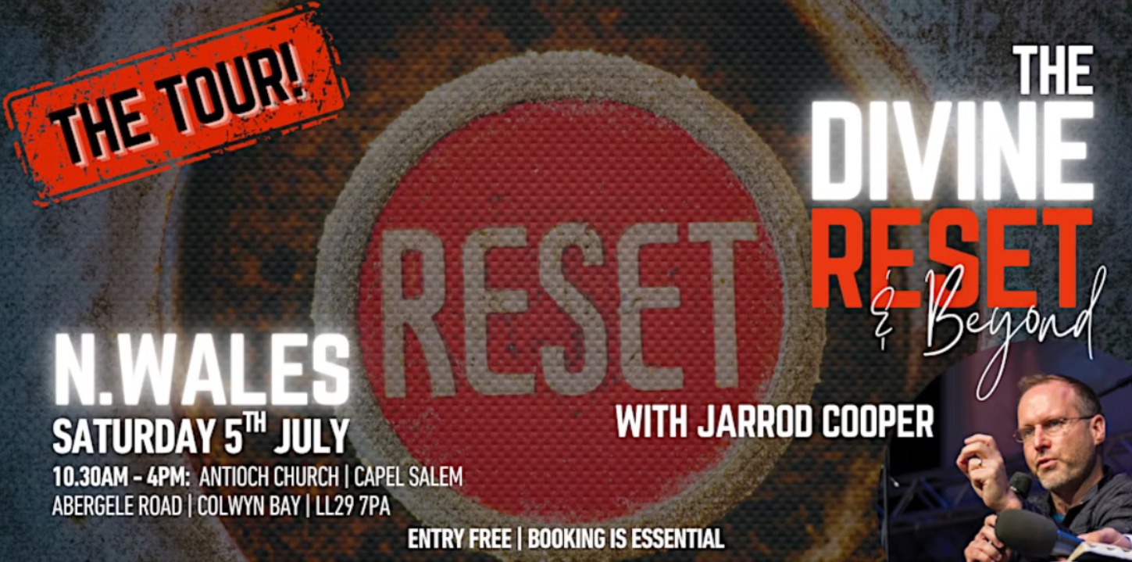
Jarrod Cooper - The Divine Reset
These are not ordinary times—can you sense the atmosphere shifting? Are old ways not
working for you anymore, but you’re not sure what to do?
Join us on July 5th for a powerful day of worship, encounter, teaching, and prophetic ministry
with Jarrod Cooper—the leader of a church who sold their building and bought an outdoor
adventure park instead!
Churches together in Britain and Ireland
The latest CTBI Newsletter, Witnessing Together’ is available now.
You can read it here.

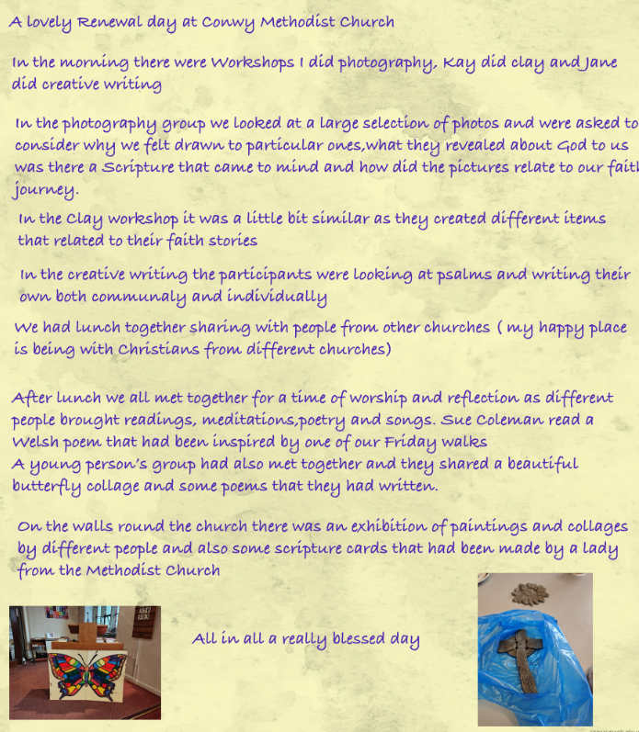
Celtic Worship
St Michael's, Dolwen Rd, Betws-yn-Rhos, Abergele LL22 8AW
4pm every 3rd Sunday of the month

Key Features of a Celtic Service:

Contemplative and Reflective: Celtic services prioritize a quiet, meditative space for prayer and reflection.

Liturgical Traditions: They often draw upon Iona and Northumbria Community liturgies, which are known for their emphasis on prayer and reflection.
Contemporary Language: While drawing on tradition, Celtic services often use contemporary language and hymns to make them accessible to a wider audience.
Musical Variety: You might hear sacred music played on a variety of instruments, including flutes, harps, cellos, and violins.
Inclusive and Welcoming: These services are often designed to be inclusive and welcoming to people of all ages and backgrounds.
Special Services: Some churches may offer special services with specific themes, such as Taizé, Celtic, or healing and wholeness.

Worship in the Wild
See https://caruconwy.com/worship/worship-in-the-wild/ for details.

Know Your Neighbour Talks

Reverend Dr. James Garnett : The Seven Year Itch
James reflects on the series of careers that has brought him into ministry.
Refreshments will be served 7pm 25th June St David's Church

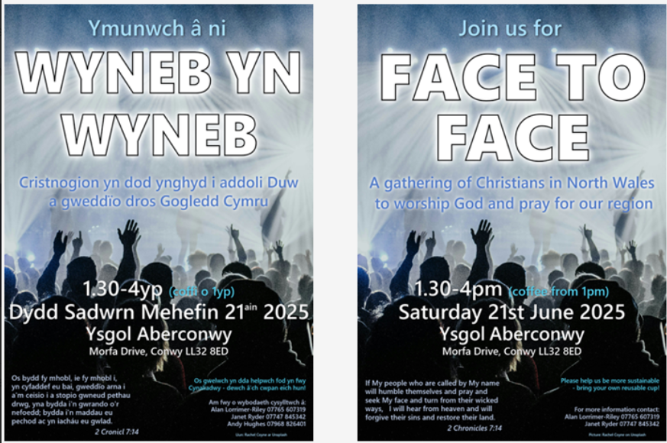
New partnership with Linking Lives UK to support and grow befriending in Wales

A new partnership between Befriending Networks and Linking Lives UK has been formed to tackle social isolation and loneliness in Wales. In the year ahead, the two organisations will work together to promote and support befriending.
Befriending is a relationship supported by an organisation to enable meaningful connections. A volunteer befriender is matched with an individual, and they will provide telephone befriending, home visiting or do activities together in their community.

You can find out more here.

Suicide Awareness

The Connexional Safeguarding Team is organising a webinar on the theme of Suicide Awareness on Tues 15 July, 11am - 12.30pm.

Organised by the Connexional Safeguarding Team, this 90 minute webinar will be facilitated by David Brown, Head of Training and Development at If U Care Share foundation, a suicide prevention charity based in the North East of England.
The webinar will cover:
An introduction to suicide prevalence / Language around suicide / Impact of suicide / Available support

Please sign up for the webinar here:
www.methodist.org.uk/safeguarding/webinars/suicide-awareness-webinar-tuesday-15-july-2025/

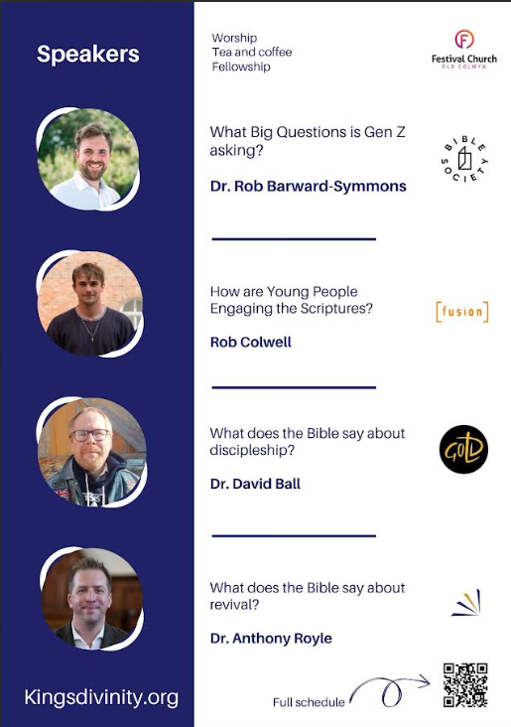
DATES FOR YOUR DIARY

Circuit Bible Study which will focus on the Gospel of John.  St David’s Church, Craig-y-Don  7.30 to 9.00 p.m |  | Circuit Bible Study  Bible Month: The Gospel of John |  | If you would like to join in, could you please let David Lamb know by email or phone, so that he can make sure that there are enough booklets for everybody.  Email: david.a.lamb@btinternet.com Phone: 01492 549111
 |  | Session 1: June 30th
 |  | Session 2: July 7th
 |  | Session 3: July 14th
 |  | Session 4: July 21st
29th June @ St John's Old Colwyn 6pm |  | Old Colwyn Churches Together  Praise evening |  | Please contact the circuit office or Liz Royle, Outreach worker for more information
Saturday July 19th at Llanddulas 9.30am |  | Circuit Prayer Breakfast |  | Please contact Deacon Linda Brown or the circuit office for more information.
REGULAR EVENTS

Monday |  | Toddlers Sing and play |  | St Johns, Llandudno  09:45am -10:45am
 |  | Circuit Choir |  | St Davids, Craig y Don  4.00 - 5.00 pm
 |  | Hand Bell Ringers Practice  open to anyone |  | St Johns, Llandudno  12.30pm to 2pm
Tuesday |  | Coffee and reflection |  | St John's, Conwy  10.00 -12.00pm
 |  | Circuit Prayer Gathering |  | Llanddulas  10.30am
 |  | Circuit Prayer Gathering |  | Conwy  11.45am
 |  | Open House |  | St Davids Craig y Don  11am to 2pm
Wednesday |  | Coffee morning and reflection |  | St David's, Craig y Don  10.00am – 12.00pm
 |  | “Butterflies” Toddlers |  | St John's Conwy  9.30am-11.00am
Thursday |  | Circuit Prayer Gathering |  | Old Colwyn  10.30am
 |  | Prayers for Healing & Wholeness  (If you have any prayer requests please bring on the day) |  | St John's, Llandudno  1:45pm-2:15pm
Friday |  | Circuit Prayer Gathering |  | St Johns, Llandudno  9.30am
 |  | Community Cafe |  | St Johns, Llandudno  10am-12pm
 |  | Trinity Toddlers |  | Trinity, Prestatyn  9.30am-11.00am
 |  | Toddlers Group |  | St Davids, Craig y Don  9.00am-11.00am
 |  | Warm welcome |  | St Johns, Llandudno  1.00pm – 4.00pm
USEFUL TO KNOW….
Superintendent | Rev Dr James Garnett  01492596006 |  | james.garnett@methodist.org.uk
Deacon Linda Brown | Deacon Linda Brown  01745 823732 |  | deaconlindabrown@gmail.com
Outreach worker | Liz Royle  07866177832 |  | cpmclayworkerlr@gmail.com
Childrens’ & Families worker | Jodie James  07886177560 |  | cpmclayworkerjj@gmail.com
Circuit Finance Office | Paula Hammond  01492878447 |  | cpmfinance2021@gmail.com
Circuit Administrator / Safeguarding | Hayley J. Allport  014920860439 |  | cpmcoffice2@gmail.com

Podcasts, Websites, Newsletters & Publications that may be of interest..

The Methodist Church | Click here to visit.
Our Circuit website | Click here to Visit
Methodist Property Matters | Click here to Visit
CTBI - Churches together in Britain and Ireland  Serving the churches of Britain and Ireland on the shared journey towards full visible unity in Christ. | Click here to visit.
All We Can - An international relief and development movement, rooted in the Christian faith. Together, we're finding solutions to poverty. | Click to visit
Cytûn - Churches together in Wales website | Click here to visit
The Well - For children, youth, schools and family workers | Click here to visit
JPIT - Joint Public Issues Team (Churches working for Peace and Justice) | Click here to visit
Fund for Human need | Click here to visit

