
Circuit News

For members of our circuit and friends, please find the latest circuit news......
Remember that not everyone has access to the internet. Perhaps there are visitors to your church who may not be on our circulation list...
Please feel free to print out a few copies to spread the news!
Some churches have also included a link in their own newsletter which allows people to click to access the bulletin directly! Great idea!
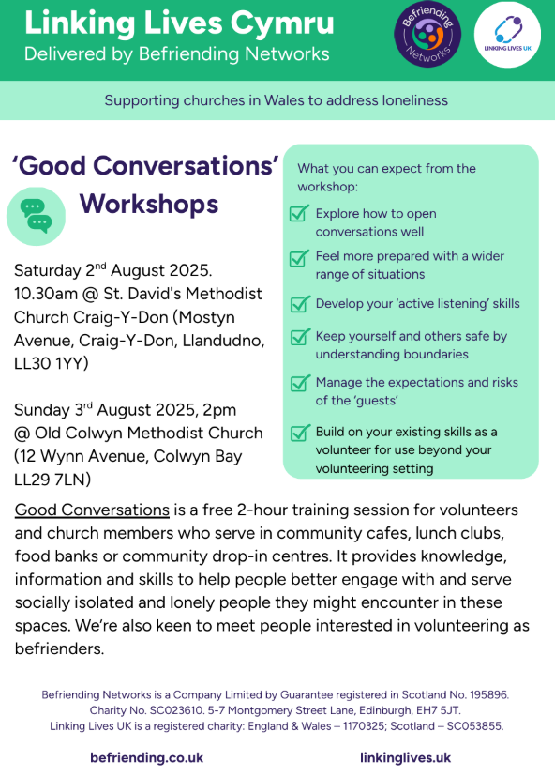
Anna Chaplaincy Network

BRF Ministries are delighted to share details of a new collaboration with AtaLoss, the leading Christian charity helping bereaved people find support and wellbeing.

AtaLoss is the home of the award-winning The Bereavement Journey® - a group-based programme for bereaved people run by some Anna Chaplains. Offered by churches for their communities it provides 7 sessions of films and facilitated discussion for adults to process the impact of a death, in a safe space with others, and where the 7th session is an optional session on faith questions in bereavement from a Christian perspective (See www.thebereavementjourney.org)

AtaLoss is expanding rapidly to become the go-to place for bereaved people to find out about the support that is available to them, through their UK wide signposting website AtaLoss.org (AtaLoss.org: UK wide bereavement signposting and information website | Find Support Now).

Through their Loss and Hope website (Equipping Churches in Bereavement Support - Loss and Hope) AtaLoss is also helping churches to be more bereavement friendly, by training and resourcing pastoral and church leaders.

Anna Chaplaincy is working with church engagement lead at AtaLoss, Rev Nicky Grey, to enable mutually fruitful links with Anna Chaplains. Nicky wrote our brand new Easy Guide – Easy Guide 14: How to Support a Bereaved Person (Easy Guides & Church Guides | Anna Chaplaincy).

Methodist Women in Britain
The latest Methodist Women in Britain Newsletter is available here

Something exciting is happening in the Methodist Church
God is calling ordinary people to begin new forms of church, and we’re investing millions of pounds over the next seven years to make that a reality.
Join our movement to start New Places for New People (NPNP) – new Christian communities for people with questions about life and faith who struggle to connect with existing forms of church. We're deeply committed to low-income communities, and prioritising new forms of church amongst and led by people experiencing poverty through our Church at the Margins (CAM) programme.

A Message from St John’s Methodist Church, Llandudno
St John’s Methodist Church, Llandudno, are carrying out research about how our building might be used for events and activities that beneﬁt our whole community.
We are keen to hear the views of church and circuit, local residents, our local community and those who visit the area, regardless of whether you have any involvement with the church or not. All responses are anonymous and the survey will take less than 10 minutes to complete. As well as completing the survey yourself, please forward the link below to anyone you know who might be willing to do so.
https://link.webropol.com/s/StJohnsLlandudno

Paper copies of the survey are available at St John's.

A spectacular theatre production of ..

The Lion, the Witch and the Wardrobe
is coming to:
Llandudno's Venue Cymru, The Promenade, LL30 1BB
on
Tuesday 5th August - Sat. 9th August as part of a UK-wide tour throughout 2025.

This production played for five months in London's West End at the theatre which ran Cats.
For details and to book go to: lionwitchonstage.com
To get an idea of what to expect see youtube.com/watch?v=ihLwncHYq1U

Donate Your Unwanted Lego
Got old Lego gathering dust?
Help us bring creativity and joy to more children—donate your unwanted Lego today!
Every brick makes a difference. Drop off your Lego with Liz Outreach worker at St John’s- Llandudno and give it a new life in the hands of young builders.
Email Liz to arrange drop off- cpmclayworkerlr@gmail.com

President and Vice-President 2025/2026

The Methodist Conference elected the Revd Richard Andrew to serve as President and Matthew Forsyth to serve as Vice-President, starting their year of office on Saturday 28 June 2025. You can find out all about them here.

An invite to Fun Palaces Workshop
At present, Menter Iaith Conwy is working in partnership with Fun Palaces andthe National Trust to breathe new life into Tŷ Aberconwy. Fun Palaces Fun Palaces Cymru support local people to co-create their own cultural and community events across Britain and beyond, sharing and celebrating the unique brilliance that exists in everyone. They collaborate with buildings, venues, organisations, groups, and individuals to help shape events that highlight the skills, passion and enthusiasm of each place and community. Fun Palaces encourage active and practical participation for people of all ages and experience levels.
Rachel Attfield from Fun Palaces will be holding a two-hour workshop on Wednesday 23th July, from 2.00 to 4.00pm, to introduce herself and discuss with potential partners how to go about organising a Fun Palace Day with the local community.
Following this, our aim is to coordinate local Fun Palace events during October,based at Tŷ Aberconwy and other nearby locations. We would be delighted if you could join us. From our previous experience with Fun Palaces, we believe their work will be of interest to you and could offer valuable support to you and your organisation.
You can register with the following link https://www.tickettailor.com/events/funpalaces/1764879/r/website
or contact me personally.
Cofion Cynnes, Meirion Ll Davies Prif Weithredwr / Chief Executive
Menter Iaith Conwy
Menter Iaith Conwy, Y Sgwar, Llanrwst, Conwy, LL26 0LD
01492642357
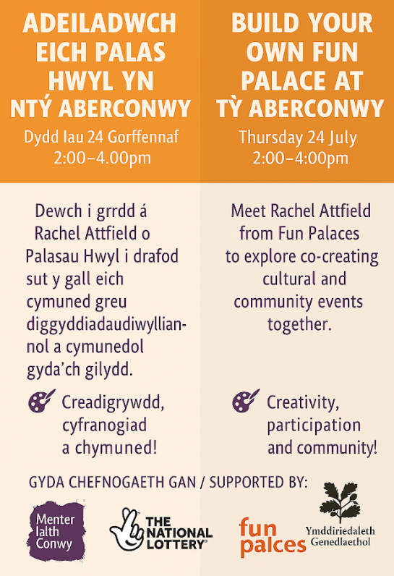

DATES FOR YOUR DIARY

Circuit Bible Study which will focus on the Gospel of John.  St David’s Church, Craig-y-Don  7.30 to 9.00 p.m |  | Circuit Bible Study  Bible Month: The Gospel of John |  | If you would like to join in, could you please let David Lamb know by email or phone, so that he can make sure that there are enough booklets for everybody.  Email: david.a.lamb@btinternet.com Phone: 01492 549111
 |  | Session 4: July 21st
Saturday July 19th at Llanddulas 9.30am |  | Circuit Prayer Breakfast |  | Please contact Deacon Linda Brown or the circuit office for more information.
REGULAR EVENTS

Monday |  | Toddlers Sing and play |  | St Johns, Llandudno  09:45am -10:45am
 |  | Circuit Choir |  | St Davids, Craig y Don  4.00 - 5.00 pm
 |  | Hand Bell Ringers Practice  open to anyone |  | St Johns, Llandudno  12.30pm to 2pm
Tuesday |  | Coffee and reflection |  | St John's, Conwy  10.00 -12.00pm
 |  | Circuit Prayer Gathering |  | Llanddulas  10.30am
 |  | Circuit Prayer Gathering |  | Conwy  11.45am
 |  | Open House |  | St Davids Craig y Don  11am to 2pm
Wednesday |  | Coffee morning and reflection |  | St David's, Craig y Don  10.00am – 12.00pm
 |  | “Butterflies” Toddlers |  | St John's Conwy  9.30am-11.00am
Thursday |  | Circuit Prayer Gathering |  | Old Colwyn  10.30am
 |  | Prayers for Healing & Wholeness  (If you have any prayer requests please bring on the day) |  | St John's, Llandudno  1:45pm-2:15pm
Friday |  | Circuit Prayer Gathering |  | St Johns, Llandudno  9.30am
 |  | Community Cafe |  | St Johns, Llandudno  10am-12pm
 |  | Trinity Toddlers |  | Trinity, Prestatyn  9.30am-11.00am
 |  | Toddlers Group |  | St Davids, Craig y Don  9.00am-11.00am
 |  | Warm welcome |  | St Johns, Llandudno  1.00pm – 4.00pm
USEFUL TO KNOW….
Superintendent | Rev Dr James Garnett  01492596006 |  | james.garnett@methodist.org.uk
Deacon Linda Brown | Deacon Linda Brown  01745 823732 |  | deaconlindabrown@gmail.com
Outreach worker | Liz Royle  07866177832 |  | cpmclayworkerlr@gmail.com
Childrens’ & Families worker | Jodie James  07886177560 |  | cpmclayworkerjj@gmail.com
Circuit Finance Office | Paula Hammond  01492878447 |  | cpmfinance2021@gmail.com
Circuit Administrator / Safeguarding | Hayley J. Allport  014920860439 |  | cpmcoffice2@gmail.com

Podcasts, Websites, Newsletters & Publications that may be of interest..

The Methodist Church | Click here to visit.
Our Circuit website | Click here to Visit
Methodist Property Matters | Click here to Visit
CTBI - Churches together in Britain and Ireland  Serving the churches of Britain and Ireland on the shared journey towards full visible unity in Christ. | Click here to visit.
All We Can - An international relief and development movement, rooted in the Christian faith. Together, we're finding solutions to poverty. | Click to visit
Cytûn - Churches together in Wales website | Click here to visit
The Well - For children, youth, schools and family workers | Click here to visit
JPIT - Joint Public Issues Team (Churches working for Peace and Justice) | Click here to visit
Fund for Human need | Click here to visit
Methodist Women in Britain | Click here to visit

