For members of our circuit and friends, please find the latest circuit news......
Remember that not everyone has access to the internet. Perhaps there are visitors to your church who may not be on our circulation list...
Please feel free to print out a few copies to spread the news!
Some churches have also included a link in their own newsletter which allows people to click to access the bulletin directly! Great idea!

Methodist Intergenerational Prayer Cards

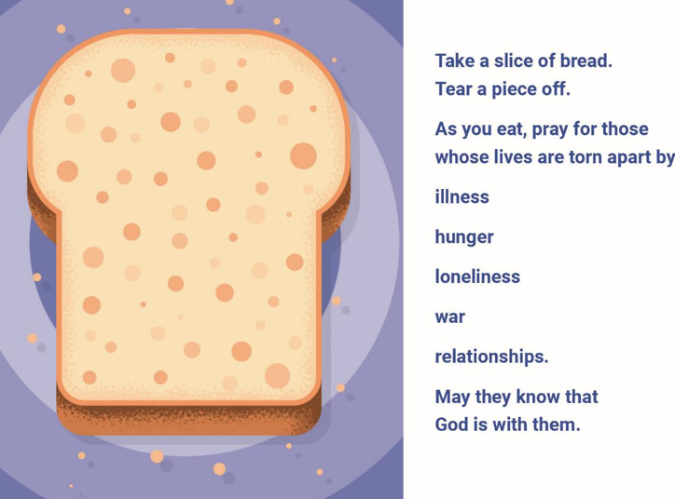
The Walking Group
The Walking Group was hoping to resume on the first Monday in March i.e. 3rd March, however Graham is no longer able to lead the group due to a pending operation on his ankle. I think therefore we need instead of a walk a meeting to discuss the way forward for the walking group in the absence of a leader. Would all interested parties therefore meet at St David’s Methodist Church, Craig Y Don on the 10th March at 10 am to discuss where we go from here. Maria Carter.

A More Able Church Webinar
Led by members of the charity “Through the Roof”

Tuesday 25th March 2025, 7 pm gathering for introductions with a 7.30 pm start on Zoom

Please contact the Training and Development Officer for further details and to register, tdourcwales@gmail.com

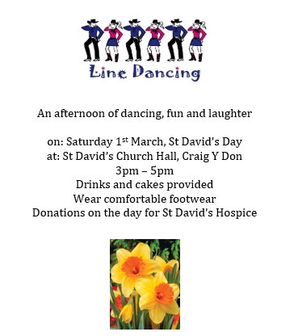

Please find attached the latest CTBI Update which includes more details on the following key highlights:

Lent 2025 – Christian Unity in a Fragmenting World
This Lenten Resource follows on from the Week of Prayer for Christian Unity theme this year, which invites us to explore together the enduring relevance of the first ecumenical council of the Church which took place in Nicaea 1700 years ago.
Lent 2025 – Christian Unity in a Fragmenting World - CTBI

Dancing with Diversity – Revisiting the Scandal of Particularity in the context of inter-religious dialogue
Conference papers are available from this event.
Conference papers: Dancing with Diversity - Revisiting the Scandal of Particularity in the context of inter-religious dialogue - CTBI

David Goodbourn Lecture 2025
Just knowing: How do we create knowledge that does justice to marginalised voices?
David Goodbourn Lecture 2025 - CTBI

Standing Together Weekend 2025
Synergy Network event.
Standing Together Weekend 2025 - CTBI

Prayer
Prayer for those who are fleeing danger - CTBI

DATES FOR YOUR DIARY

Saturday 22 February, 12.30-3.30 at St John's Methodist Church, Llandudno  Saturday 15 March, 12.30-3.30 at Old Colwyn Methodist Church |  | Exploring Methodist Membership  Are you new to the Methodist Church? Would you like to find out more about the Christian faith in the context of Methodism? Have you been attending church for a while and want to find out more? |  | Please email james.garnett@methodist.org.uk to sign up for one of the sessions to explore Methodist membership. Both sessions will be the same and are open to people from all the local churches. More sessions can be provided in the future if needed.
Wednesday evenings,  8-9pm  The first session will be on Wednesday 12th March, and the last on Wednesday 16th April. |  | Circuit Lent Bible Study: Growth in Christ  These studies will set the weekly Gospel readings alongside our continuing journey with Elijah this year. |  | Zoom Link: Meeting ID: 849 6735 1356  Passcode: 210095 https://us02web.zoom.us/j/84967351356?pwd=NUgaH2eFa7kV1b2oJ5P68sqEJEra6u.1
Ken Young : Painting the Town Red and Every Day is a School Day!
St David's Church, Craig y Don on February 26th at 7pm |  | Ken is an experienced and engaging speaker who has a host of stories as he navigates his life as a lecturer and Christian. |  | Returning host will be Graham Morgan with delicious refreshments being provided.
Conwy and Prestatyn Circuit MWIB
Saturday March 1st 2025  at Saint David’s Methodist Church, Craig y Don, LL30 1YY |  | “DO THE LITTLE THINGS”  (a Welsh inspired light lunch will be provided if you have any dietary requirements please contact Deacon Denise Creed beforehand) |  | No charge – donations to cover costs appreciated  Refreshments from 10am  Start 10.30am - Lunch 12.30am
Safeguarding Training
Tuesday 11th March 18:30 hrs to 21:30 hrs (appx) |  | FOUNDATION MODULE safeguarding training - online |  | Contact Hayley to register anyone who needs to complete this.
REGULAR EVENTS

Monday |  | Toddlers Sing and play |  | St Johns, Llandudno  09:45am -10:45am
 |  | Circuit Choir |  | St Davids, Craig y Don  4.00 - 5.00 pm
 |  | Hand Bell Ringers Practice  open to anyone |  | St Johns, Llandudno  12.30pm to 2pm
Tuesday |  | Coffee and reflection |  | St John's, Conwy  10.00 -12.00pm
 |  | Circuit Prayer Gathering |  | Llanddulas  10.30am
 |  | Circuit Prayer Gathering |  | Conwy  11.45am
Wednesday |  | Coffee morning and reflection |  | St David's, Craig y Don  10.00am – 12.00pm
 |  | “Butterflies” Toddlers |  | St John's Conwy  9.30am-11.00am
Thursday |  | Circuit Prayer Gathering |  | Old Colwyn  10.30am
 |  | Prayers for Healing & Wholeness  (If you have any prayer requests please bring on the day or send them to eldensmall376@gmail.com) |  | St John's, Llandudno  1:45pm-2:15pm
Friday |  | Circuit Prayer Gathering |  | St Johns, Llandudno  9.30am
 |  | Community Cafe |  | St Johns, Llandudno  10am-12pm
 |  | Trinity Toddlers |  | Trinity, Prestatyn  9.30am-11.00am
 |  | Toddlers Group |  | St Davids, Craig y Don  9.00am-11.00am
 |  | Warm welcome |  | St Johns, Llandudno  1.00pm – 4.00pm
USEFUL TO KNOW….
Superintendent | Rev Dr James Garnett  01492596006 |  | james.garnett@methodist.org.uk
Deacon Linda Brown | Deacon Linda Brown  01745 823732 |  | deaconlindabrown@gmail.com
Outreach worker: | Liz Royle  07866177832 |  | cpmclayworkerlr@gmail.com
Childrens’ & Families worker | Jodie James  07886177560 |  | cpmclayworkerjj@gmail.com
Circuit Finance Office | Paula Hammond  01492878447 |  | cpmfinance2021@gmail.com
Circuit Administrator / Safeguarding | Hayley J. Allport  014920860439 |  | cpmcoffice2@gmail.com

Podcasts, Websites, Newsletters & Publications that may be of interest..
The Methodist Church | Click here to visit.
Our Circuit website | Click here to Visit
Methodist Property Matters | Click here to Visit
CTBI - Churches together in Britain and Ireland  Serving the churches of Britain and Ireland on the shared journey towards full visible unity in Christ. | Click here to visit.
All We Can - An international relief and development movement, rooted in the Christian faith. Together, we're finding solutions to poverty. | Click to visit
Cytûn - Churches together in Wales website | Click here to visit
The Well - For children, youth, schools and family workers | Click here to visit
JPIT - Joint Public Issues Team (Churches working for Peace and Justice) | Click here to visit

