
Circuit News

For members of our circuit and friends, please find the latest circuit news......
Remember that not everyone has access to the internet. Perhaps there are visitors to your church who may not be on our circulation list...
Please feel free to print out a few copies to spread the news!
Some churches have also included a link in their own newsletter which allows people to click to access the bulletin directly! Great idea!
Know Your Neighbour Talks
September 24th Wednesday 7pm Dt David's Church

Jonathan Williams will take us on a tour of the criminal underworld with a focus on busting fraud and investigating crime.
Watch out there is a thief about !
(This is the real deal beware of fakes!)
WALKING/STROLLING GROUP
The next walk will be on Thursday 4th September, meeting, as usual, at 10am at St David’s in Craig y Don. Options include from Bryn Pydew and above Trefriw, to be agreed on the day by those present. In either case our cars will do the hard work of getting us up to the starting point. As with recent walks this one will be buggy-friendly, last about an hour and cover just over 2 miles total. This might not seem much but it has proved just right for those who come. What with enjoying the views and looking at points of interest, there is plenty of opportunity for conversation and getting to know one another.
Martin Snellgrove, St David’s. martin.snellgrove@hotmail.com email. 07853 150826 text

Churches Together in Britain and Ireland
Please find attached the CTBI Update featuring the latest news, events and resources from CTBI and its member networks, including:
Season of Creation resources and Upcoming events
with details of the Week of Prayer for Christian Unity 2026 resources coming soon.

If you have any questions or would like any further information regarding the work of CTBI, please do not hesitate to contact communications@ctbi.org.uk

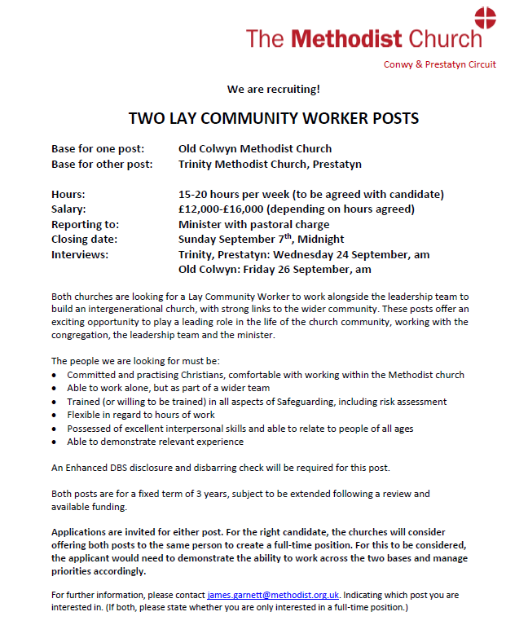
Thank You for Supporting St John’s Teddy Zip Wire

A huge thank you to everyone who joined us at St John’s in Llandudno last Saturday. The Teddy Zip Wire was a wonderful success—bringing fun, mission, and fundraising together in the most delightful way!
Before their daring rides, some teddies even had to pass a “health check” to make sure they were fit enough for the “British Bearways” zip line. Stewards and visitors alike were treated to the sight of brave bears whizzing past the church windows, much to everyone’s amusement.
The event created a real buzz in the town, and it was lovely to see participants later proudly wearing their “My teddy rode the St John’s Zip Line” stickers as they strolled through Llandudno.
We are so grateful for your support—thank you for helping to make this event such a memorable day! We are already thinking of how we can do a Christmas event incorporating the Teddy Zip Line… (assuming that the scaffolding is still in situ / but hoping it’s not!)

Postcode Community Trust
Liz Royle recently joined a webinar by the Postcode Community Trust. She said that she found it helpful and informative and had everything you need to make a great application! If you are interested, you can find a lot of the information here and the slideshow from the webinar can be found my contacting Hayley at the Circuit Office.

This round of grant funding will open on Thursday 28th August and the deadline for applying is Monday 8th September.

Postcode Community Trust supports smaller charities and good causes in Wales to make a difference to their community for the benefit of people and planet.

Find out which trust to apply to for funding using the postcode trust finder.

SON Plan

The latest quarterly preaching plan is now available and can be found Here
Message from Chrisitan Aid about the 80th anniversary service in Cardiff

We would like to extend our warmest invitation for you to attend a special evening of worship, inspiration and thanksgiving in Wales to mark 80 years of Christian Aid.

Christian Aid was founded by the churches in Britain and Ireland to respond to the refugee crisis in Europe in 1945 at the end of the Second World War. For eight decades, Christian Aid has been an expression of faith in the unstoppable power of hope to create a more just and peaceful world. Today, it is an incredible movement of people and partners - a movement that many of our communities in Wales have been a part of since near the very beginning.
Sign up
Details:
- Date: Wednesday 17 September 2025
- Time: Service 6.30-7.30pm. (with light refreshments before the service from 5.30pm)
- Location: Tabernacl Chapel, the Hayes, Cardiff City Centre.

We will be joined by Christian Aid’s Directors and Board of Trustees, with addresses by Patrick Watt, Christian Aid CEO, Bishop Sarah Mullally, Christian Aid Chair and Bishop of London, and Jane Hutt MS, Welsh Government Cabinet Secretary for Social Justice.

To learn more about the evening and to register, please visit our website.

DATES FOR YOUR DIARY

“Incredible Edible” at Old Colwyn Church

You don’t need to know anything about gardening to join in; just a willingness to get involved and eat cake!
Rake & Cake |  |  |  | 20th September |  |  |  | 10 – 12pm
Monday 11th–Saturday 30th August |  |  | Lego Exhibition |  |  | St Johns, Llandudno
Sunday 14 September 2025 |  |  | Deadline for articles for the Autumn Circuit Magazine |  |  | Please contact Maria at St Davids for more information maria.s.carter7@gmail.com
Sunday 7 December 2025 |  |  | Deadline for articles for the Winter Circuit Magazine
REGULAR EVENTS

Monday | Toddlers Sing and play |  |  |  |  |  | St Johns, Llandudno  09:45am -10:45am
 | Circuit Choir |  |  |  |  |  | St Davids, Craig y Don  4.00 - 5.00 pm
 | Hand Bell Ringers Practice  open to anyone |  |  |  |  |  | St Johns, Llandudno  12.30pm to 2pm
Tuesday | Coffee and reflection |  |  |  |  |  | St John's, Conwy  10.00 -12.00pm
 | Circuit Prayer Gathering |  |  |  |  |  | Llanddulas  10.30am
 | Circuit Prayer Gathering |  |  |  |  |  | Conwy  11.45am
 | Open House |  |  |  |  |  | St Davids Craig y Don  11am to 2pm
Wednesday | Coffee morning and reflection |  |  |  |  |  | St David's, Craig y Don  10.00am – 12.00pm
 | “Butterflies” Toddlers |  |  |  |  |  | St John's Conwy  9.30am-11.00am
Thursday | Circuit Prayer Gathering |  |  |  |  |  | Old Colwyn  10.30am
 | Prayers for Healing & Wholeness  (If you have any prayer requests, please bring on the day) |  |  |  |  |  | St John's, Llandudno  1:45pm-2:15pm
Friday | Circuit Prayer Gathering |  |  |  |  |  | St Johns, Llandudno  9.30am
 | Community Cafe |  |  |  |  |  | St Johns, Llandudno  10am-12pm
 | Trinity Toddlers |  |  |  |  |  | Trinity, Prestatyn  9.30am-11.00am
 | Toddlers Group |  |  |  |  |  | St Davids, Craig y Don  9.00am-11.00am
 | Warm welcome |  |  |  |  |  | St Johns, Llandudno  1.00pm – 4.00pm
USEFUL TO KNOW….
Superintendent |  | Rev Dr James Garnett  01492596006 |  |  | james.garnett@methodist.org.uk
Deacon Linda Brown |  | Deacon Linda Brown  01745 823732 |  |  | deaconlindabrown@gmail.com
Outreach worker |  | Liz Royle  07866177832 |  |  | cpmclayworkerlr@gmail.com
Childrens’ & Families worker |  | Jodie James  07886177560 |  |  | cpmclayworkerjj@gmail.com
Circuit Finance Officer |  | Paula Hammond  01492878447 |  |  | cpmfinance2021@gmail.com
Circuit Administrator / Safeguarding |  | Hayley J. Allport  014920860439 |  |  | cpmcoffice2@gmail.com

Podcasts, Websites, Newsletters & Publications that may be of interest..

The Methodist Church | Click here to visit.
Our Circuit website | Click here to Visit
Methodist Property Matters | Click here to Visit
CTBI - Churches together in Britain and Ireland  Serving the churches of Britain and Ireland on the shared journey towards full visible unity in Christ. | Click here to visit.
All We Can - An international relief and development movement, rooted in the Christian faith. Together, we're finding solutions to poverty. | Click to visit
Cytûn - Churches together in Wales website | Click here to visit
The Well - For children, youth, schools and family workers | Click here to visit
JPIT - Joint Public Issues Team (Churches working for Peace and Justice) | Click here to visit
Fund for Human need | Click here to visit
Methodist Women in Britain | Click here to visit

