
Circuit News

For members of our circuit and friends, please find the latest circuit news......
Remember that not everyone has access to the internet. Perhaps there are visitors to your church who may not be on our circulation list...
Please feel free to print out a few copies to spread the news!
Some churches have also included a link in their own newsletter which allows people to click to access the bulletin directly! Great idea!
Circuit Magazine
Good News! Our New Circuit Magazine Is Launching

We’re delighted to announce that the development work to produce a Circuit-wide magazine has been a success! The processes for editing, layout, and distribution—both in print and digital formats—are now in place.
This new magazine will be a wonderful platform for sharing stories, insights, and news from across our churches. It's a great opportunity for us to get to know more about one another and the life of our Circuit.
Contributions are warmly invited from all members and friends of Methodism. The editorial approach will be open and encouraging, welcoming a wide range of authors and subject matter. We’re pleased that Rev Dr James Garnett has agreed to act as Consulting Editor, helping to ensure all articles align with Methodist Conference policies and values.
Experienced graphic designer Maria Carter will be responsible for gathering articles and shaping the magazine’s layout, ensuring it looks professional and inviting.
Please spread the word in your congregations and encourage people to contribute. Articles, reflections, photos, and other creative pieces should be sent initially to Maria at:
 maria.s.carter7@gmail.com
 AUTUMN DEADLINE: Sunday 14 September 2025
 WINTER DEADLINE: Sunday 7 December 2025

Let’s make this magazine a vibrant reflection of our Circuit life—by the people, for the people!

+++++++ Stop Press ! +++++++
We have been notified that unfortunately the workshop leader for the events at St David's on Saturday morning and at Old Colwyn on Sunday afternoon is not able to be here. We hope to re-schedule the workshops in due course.

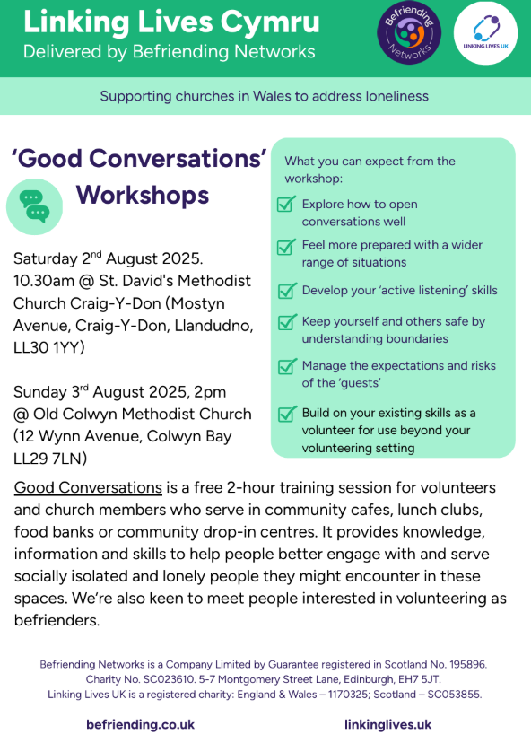

Easyfundraising

We are offering a FREE webinar in conjunction with easyfundraising.
Wanting to access a new funding stream for your church?
easyfundraising is a free to use fundraising platform which your church can use to receive unrestricted funding on an ongoing basis. We want to help your church access this exciting opportunity to grow your churches finances.
What: Meet the Funder: easyfundraising. Free unrestricted funding for your church
When: Thursday 25th September 2025, 11am – 12noon
Where: Online, via Zoom
Registration link: https://us02web.zoom.us/meeting/register/HNiLYOa1Qvue1q7HtodBXQ
easyfundraising is a free to use fundraising platform which your church can use to receive unrestricted funding on an ongoing basis. easyfundraising is trusted by 100,000+ churches, community groups, charities and voluntary organisations already and over £60m has been raised to date. This is an easy and effective way to boost your funds so do come along to find out more.
easyfundraising’s Church Fundraising Manager Becky Coleman will:
- Explain and demonstrate how it works
- Show you how to get started
- Show you how to make the most of it
- Answer all your questions
To find out more about easyfundraising and set up a free your easyfundraising page for your church ahead of the session, visit https://www.easyfundraising.org.uk/acat or contact becky@easyfundraising.org.uk

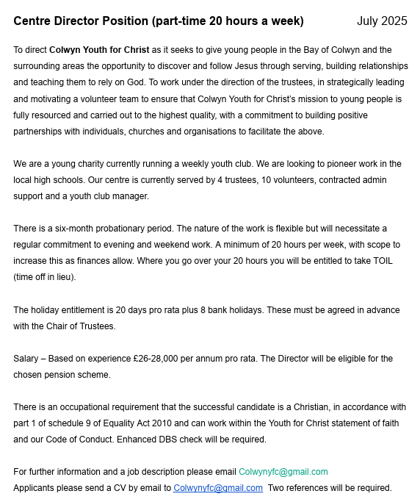
We are recruiting!
FINANCE OFFICER
Base: St John’s Methodist Church, Llandudno Hours: 8 hours per week
Salary: £17.62 per hour
Reporting to: Minister with pastoral charge
Closing date: Sunday 10 August, midnight Interviews: Monday 18 August, afternoon
We are looking for a part-time Finance Officer to manage income and expenditure of the church, prepare the accounts and work with the Trustees to prepare and monitor an annual budget. The role will involve liaising with volunteers in the church, including the Treasurer, in support of special events and ongoing activities. The hours can be worked flexibility over the month in negotiation with the church, with a minimum of 2 hours a week on site.

Introducing Lucy – A Message from Zoya

I am introducing Lucy, a pastoral chaplain with the Church in Wales, who I support with her studies at St Padarn's in South Wales. Lucy supports neurodiverse people who attend churches that she is involved with.

She is looking to work with a variety of churches and organisations that are, or that want to, meet the needs of neurodiverse people through inclusive worship.

Lucy would be delighted to meet with you, as I have told her about the circuit worship you are all involved with through ‘You, Me and God’. Lucy has highlighted that she wants to include neurotypical people, too! Please contact Lucy via Zoya at Conwy.

Thank you. Zoya

Questionnaire

As you may know, St John's Llandudno is in the midst of its market research to explore possible developments for the building. Would you be willing to complete the survey, please (if you haven't already)? Here is the link https://link.webropol.com/s/StJohnsLlandudno

Also - please would you pass on the link to anyone else who might be willing to fill in the questionnaire? We're looking for as wide a range of responses as possible - from church and non-church folk.

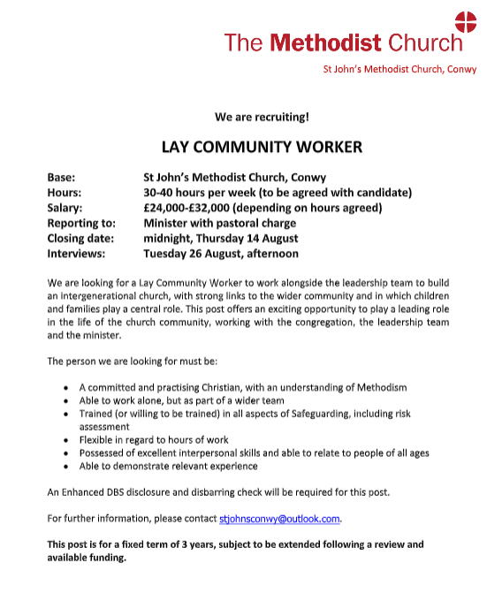
Is your church dementia friendly?

An article in the July edition of the Baptist Union Newsletter Faith & Society asks a very pertinent question: “Is your church dementia friendly?”
It is estimated that there are currently approximately 982,000 dementia sufferers in the UK, a number which is projected to rise to 1.4 million by 2040. To set this in context, in 2022, it was estimated that the Church of England had approximately 984,000 regular worshipping members in the country.
Whilst I am sure that we are aware of those among our church membership who are suffering from varying degrees of dementia, does that extend beyond a mere acknowledgement, or do we ensure that our church is truly dementia friendly?
So, what are the characteristics of a dementia friendly church?
At a very simplistic level, a dementia friendly church is one that not only recognises those members suffering in this way and their carers, but also goes further in providing practical support through a range of appropriate activities and services.
Some important considerations are as follows:
- Recognising that church members with dementia and their carers are important
- Encouraging those with dementia who can, to participate in worship
- Ensuring an accessible building environment which recognises disability
- Providing events which stimulate creativity
- Engaging with local dementia support networks
The simple truth is that God loves all those in our church fellowships, irrespective of their health.

GDPR NEWS:
Data Use and Access Act 2025 – What It Means for Us
A new law, the Data Use and Access Act 2025 (DUAA), is being phased in over the next year. It updates how organisations like churches and charities can use and share personal data.

Key points:
- We can contact people about events and fundraising unless they’ve opted out.
- Reusing personal data for research or archiving will be easier.
- Broad consent can be used for research purposes.
- Extra care is needed when services are likely to be used by children.
- Complaints must be easy to make and acknowledged within 30 days.

What we need to do:
Make sure we understand the new rules.
Check our complaints process is clear and up to date.
Review how we use personal data for marketing and events.

Lego Exhibition
The annual Lego exhibition at St John's Llandudno will take place between 11 and 30 August. There are still spaces to steward at the exhibition, bringing the opportunity to visit the exhibition and to have interesting conversations with the many visitors to it. (Also to complete part of your Circuit Pilgrimage!) If you can offer one or more 2-hour slots, please contact Lynn Brown on stjohnsllandudno@gmail.com.
DATES FOR YOUR DIARY

Free Childrens’ packed lunches 12 – 12.30pm (no booking required)
6th August |  |  | Old Colwyn Methodist Church |  |  | Old Colwyn Churches together in conjunction with Home start and Morrisons
13th August |  |  | Festival Church, Old Colwyn
20th August |  |  | Old Colwyn Methodist Church
27th August |  |  | St Catherine’s & St John the Baptist Church in Wales, Old Colwyn
“Incredible Edible” at Old Colwyn Church

You don’t need to know anything about gardening to join in; just a willingness to get involved and eat cake!
Rake & Cake |  |  | 9th August |  |  | 10 – 12pm
Rake & Cake |  |  | 20th September |  |  | 10 – 12pm
REGULAR EVENTS

Monday | Toddlers Sing and play |  |  |  | St Johns, Llandudno  09:45am -10:45am
 | Circuit Choir |  |  |  | St Davids, Craig y Don  4.00 - 5.00 pm
 | Hand Bell Ringers Practice  open to anyone |  |  |  | St Johns, Llandudno  12.30pm to 2pm
Tuesday | Coffee and reflection |  |  |  | St John's, Conwy  10.00 -12.00pm
 | Circuit Prayer Gathering |  |  |  | Llanddulas  10.30am
 | Circuit Prayer Gathering |  |  |  | Conwy  11.45am
 | Open House |  |  |  | St Davids Craig y Don  11am to 2pm
Wednesday | Coffee morning and reflection |  |  |  | St David's, Craig y Don  10.00am – 12.00pm
 | “Butterflies” Toddlers |  |  |  | St John's Conwy  9.30am-11.00am
Thursday | Circuit Prayer Gathering |  |  |  | Old Colwyn  10.30am
 | Prayers for Healing & Wholeness  (If you have any prayer requests, please bring on the day) |  |  |  | St John's, Llandudno  1:45pm-2:15pm
Friday | Circuit Prayer Gathering |  |  |  | St Johns, Llandudno  9.30am
 | Community Cafe |  |  |  | St Johns, Llandudno  10am-12pm
 | Trinity Toddlers |  |  |  | Trinity, Prestatyn  9.30am-11.00am
 | Toddlers Group |  |  |  | St Davids, Craig y Don  9.00am-11.00am
 | Warm welcome |  |  |  | St Johns, Llandudno  1.00pm – 4.00pm
USEFUL TO KNOW….
Superintendent |  | Rev Dr James Garnett  01492596006 |  | james.garnett@methodist.org.uk
Deacon Linda Brown |  | Deacon Linda Brown  01745 823732 |  | deaconlindabrown@gmail.com
Outreach worker |  | Liz Royle  07866177832 |  | cpmclayworkerlr@gmail.com
Childrens’ & Families worker |  | Jodie James  07886177560 |  | cpmclayworkerjj@gmail.com
Circuit Finance Office |  | Paula Hammond  01492878447 |  | cpmfinance2021@gmail.com
Circuit Administrator / Safeguarding |  | Hayley J. Allport  014920860439 |  | cpmcoffice2@gmail.com

Podcasts, Websites, Newsletters & Publications that may be of interest..

The Methodist Church | Click here to visit.
Our Circuit website | Click here to Visit
Methodist Property Matters | Click here to Visit
CTBI - Churches together in Britain and Ireland  Serving the churches of Britain and Ireland on the shared journey towards full visible unity in Christ. | Click here to visit.
All We Can - An international relief and development movement, rooted in the Christian faith. Together, we're finding solutions to poverty. | Click to visit
Cytûn - Churches together in Wales website | Click here to visit
The Well - For children, youth, schools and family workers | Click here to visit
JPIT - Joint Public Issues Team (Churches working for Peace and Justice) | Click here to visit
Fund for Human need | Click here to visit
Methodist Women in Britain | Click here to visit

