
Circuit News

For members of our circuit and friends, please find the latest circuit news......
Remember that not everyone has access to the internet. Perhaps there are visitors to your church who may not be on our circulation list...
Please feel free to print out a few copies to spread the news!
Some churches have also included a link in their own newsletter which allows people to click to access the bulletin directly! Great idea!

You can book your free place on any of the workshops here.
 |  |  |  |  | Global Sports Sunday 21 September 2025  All are touched by the ‘power’ of sport.  Sports Chaplaincy UK, a Body in Association of CTBI, Sports Chaplaincy UK is calling on churches all around the world to pray for the global community of sport on Global Sports Sunday. The greatest untapped mission field in the world!


Please do support the fundarising efforts at St Johns. Bring your teddy to ride with “British BEARWAYS!”- the 100 foot high zip line at St Johns, Llandudno

Safeguarding Sunday - 16 November 2025



Safeguarding Sunday 2025 is on 16 November 2025 – The Communications pack has now been launched.

Publicity says: ‘Defending the rights of vulnerable people is integral to Christian faith and teaching. Sadly, the church hasn’t always done this well. But we have a chance to change that. We are already seeing many churches take the responsibility to safeguard those in their care seriously. The theme this year is – ‘Action speaks louder!’ It's time to move beyond just talking about creating safer places, and take action towards doing it!’

Last year over 5,000 churches took part in Safeguarding Sunday, with an estimated reach of 250,000 people. This year, with your help, we can make an even greater impact to vulnerable people across the UK’ Read more on their website: Safeguarding Sunday
The 2025 Communications pack has been launched: Safeguarding Sunday Communications Pack 2025.pdf

Questionnaire

As you may know, St John's Llandudno is in the midst of its market research to explore possible developments for the building. Would you be willing to complete the survey, please (if you haven't already)? Here is the link https://link.webropol.com/s/StJohnsLlandudno

Also - please would you pass on the link to anyone else who might be willing to fill in the questionnaire? We're looking for as wide a range of responses as possible - from church and non-church folk.

All We Can
Harvest is a highlight in the All We Can calendar, and this year we are exploring the Parable of the Sower.

Join with hundreds of churches in the 2025 Harvest appeal as we seek to inspire congregations and contribute to sustainable development across the globe.

There are two options for ordering Harvest resources: physical resources to order or digital resources to download.

Click on the link below to go to the Harvest webpage to pre-order your physical resources or to download your digital resources now.
Harvest Webpage

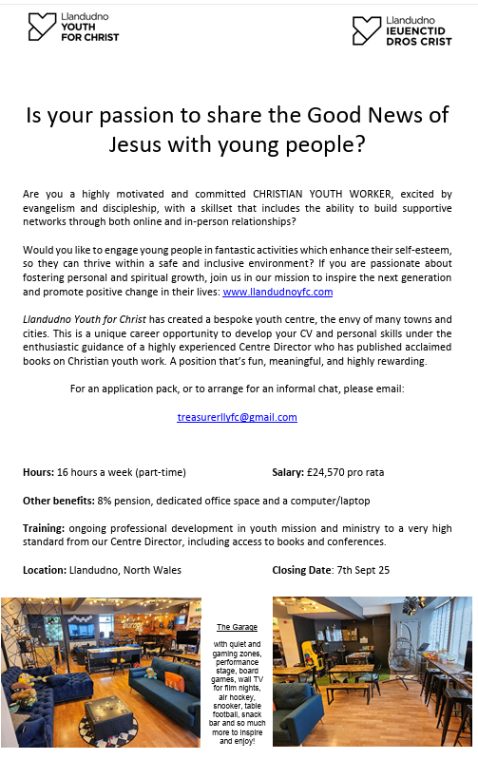
SON Plan

The latest quarterly preaching plan is now available and can be found Here
DATES FOR YOUR DIARY

Free Childrens’ packed lunches 12 – 12.30pm (no booking required)
20th August |  |  |  | Old Colwyn Methodist Church |  |  |  |  | Old Colwyn Churches together in conjunction with Home start and Morrisons
27th August |  |  |  | St Catherine’s & St John the Baptist Church in Wales, Old Colwyn
“Incredible Edible” at Old Colwyn Church

You don’t need to know anything about gardening to join in; just a willingness to get involved and eat cake!
Rake & Cake |  |  |  | 20th September |  |  |  |  | 10 – 12pm
Monday 11th–Saturday 30th August |  |  | Lego Exhibition |  |  |  | St Johns, Llandudno
Sunday 14 September 2025 |  |  | Deadline for articles for the Autumn Circuit Magazine |  |  |  | Please contact Maria at St Davids for more information maria.s.carter7@gmail.com
Sunday 7 December 2025 |  |  | Deadline for articles for the Winter Circuit Magazine
REGULAR EVENTS

Monday | Toddlers Sing and play |  |  |  |  |  |  | St Johns, Llandudno  09:45am -10:45am
 | Circuit Choir |  |  |  |  |  |  | St Davids, Craig y Don  4.00 - 5.00 pm
 | Hand Bell Ringers Practice  open to anyone |  |  |  |  |  |  | St Johns, Llandudno  12.30pm to 2pm
Tuesday | Coffee and reflection |  |  |  |  |  |  | St John's, Conwy  10.00 -12.00pm
 | Circuit Prayer Gathering |  |  |  |  |  |  | Llanddulas  10.30am
 | Circuit Prayer Gathering |  |  |  |  |  |  | Conwy  11.45am
 | Open House |  |  |  |  |  |  | St Davids Craig y Don  11am to 2pm
Wednesday | Coffee morning and reflection |  |  |  |  |  |  | St David's, Craig y Don  10.00am – 12.00pm
 | “Butterflies” Toddlers |  |  |  |  |  |  | St John's Conwy  9.30am-11.00am
Thursday | Circuit Prayer Gathering |  |  |  |  |  |  | Old Colwyn  10.30am
 | Prayers for Healing & Wholeness  (If you have any prayer requests, please bring on the day) |  |  |  |  |  |  | St John's, Llandudno  1:45pm-2:15pm
Friday | Circuit Prayer Gathering |  |  |  |  |  |  | St Johns, Llandudno  9.30am
 | Community Cafe |  |  |  |  |  |  | St Johns, Llandudno  10am-12pm
 | Trinity Toddlers |  |  |  |  |  |  | Trinity, Prestatyn  9.30am-11.00am
 | Toddlers Group |  |  |  |  |  |  | St Davids, Craig y Don  9.00am-11.00am
 | Warm welcome |  |  |  |  |  |  | St Johns, Llandudno  1.00pm – 4.00pm
USEFUL TO KNOW….
Superintendent |  | Rev Dr James Garnett  01492596006 |  |  |  | james.garnett@methodist.org.uk
Deacon Linda Brown |  | Deacon Linda Brown  01745 823732 |  |  |  | deaconlindabrown@gmail.com
Outreach worker |  | Liz Royle  07866177832 |  |  |  | cpmclayworkerlr@gmail.com
Childrens’ & Families worker |  | Jodie James  07886177560 |  |  |  | cpmclayworkerjj@gmail.com
Circuit Finance Office |  | Paula Hammond  01492878447 |  |  |  | cpmfinance2021@gmail.com
Circuit Administrator / Safeguarding |  | Hayley J. Allport  014920860439 |  |  |  | cpmcoffice2@gmail.com

Podcasts, Websites, Newsletters & Publications that may be of interest..

The Methodist Church | Click here to visit.
Our Circuit website | Click here to Visit
Methodist Property Matters | Click here to Visit
CTBI - Churches together in Britain and Ireland  Serving the churches of Britain and Ireland on the shared journey towards full visible unity in Christ. | Click here to visit.
All We Can - An international relief and development movement, rooted in the Christian faith. Together, we're finding solutions to poverty. | Click to visit
Cytûn - Churches together in Wales website | Click here to visit
The Well - For children, youth, schools and family workers | Click here to visit
JPIT - Joint Public Issues Team (Churches working for Peace and Justice) | Click here to visit
Fund for Human need | Click here to visit
Methodist Women in Britain | Click here to visit

