
Circuit News

For members of our circuit and friends, please find the latest circuit news......
Remember that not everyone has access to the internet. Perhaps there are visitors to your church who may not be on our circulation list...
Please feel free to print out a few copies to spread the news!
Some churches have also included a link in their own newsletter which allows people to click to access the bulletin directly! Great idea!
A Message from Christian Aid

At Christian Aid, we believe that the people closest to the challenges are also closest to the solutions. That’s why we put local leadership at the heart of everything we do - supporting communities to shape their futures with dignity, resilience and hope.

This month, we're sharing stories that show what that looks like in action.

In Palestine, under the pressure of occupation, local leaders are restoring childhoods, protecting families and keeping hope alive for future generations.

In Sierra Leone, communities are blending traditional knowledge with climate science adapting to a changing environment, protecting livelihoods, and pushing for policy change.

And in Ukraine, grassroots groups and marginalised communities are leading emergency responses showing just how vital flexibility and local leadership are in times of crisis.

In each of these places, your support enables Christian Aid to stand alongside courageous, creative leaders helping turn local action into lasting change

Scam Email Alert
Please be aware that a scam email is circulating, claiming to be from Rev Dr James Garnett. If you receive an unexpected message from him—especially one asking for help, money, or containing suspicious links—do not open or respond. This is a fraudulent email. Always double-check with us directly if you're unsure about any communication.
Season of Creation
The latest “Churches together in Britain and Ireland” newsletter is now available. Resources are becoming available from churches and other groups to help observe the Season of Creation / Creation Time 2025, a time to renew our relationship with our Creator and all creation through celebration, conversion, and commitment together.

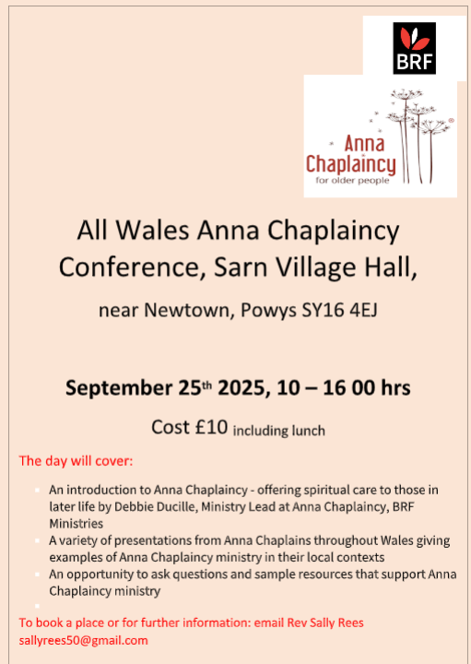
Circuit Magazine
Good News! Our New Circuit Magazine Is Launching

We’re delighted to announce that the development work to produce a Circuit-wide magazine has been a success! The processes for editing, layout, and distribution—both in print and digital formats—are now in place.
This new magazine will be a wonderful platform for sharing stories, insights, and news from across our churches. It's a great opportunity for us to get to know more about one another and the life of our Circuit.
Contributions are warmly invited from all members and friends of Methodism. The editorial approach will be open and encouraging, welcoming a wide range of authors and subject matter. We’re pleased that Rev Dr James Garnett has agreed to act as Consulting Editor, helping to ensure all articles align with Methodist Conference policies and values.
Experienced graphic designer Maria Carter will be responsible for gathering articles and shaping the magazine’s layout, ensuring it looks professional and inviting.
Please spread the word in your congregations and encourage people to contribute. Articles, reflections, photos, and other creative pieces should be sent initially to Maria at:
 maria.s.carter7@gmail.com
 AUTUMN DEADLINE: Sunday 14 September 2025
 WINTER DEADLINE: Sunday 7 December 2025

Let’s make this magazine a vibrant reflection of our Circuit life—by the people, for the people!

A Message from “Warm Welcome Space” UK

Warm Welcome is a campaign with a huge ambition - to give everyone in the UK access to a free, safe and inclusive Warm Welcome Space, bringing people together and connecting communities.

Part of this ambition is to resource, connect and champion our registered spaces to help ensure they have what they need to continue providing a safe space for those who need it the most. In order to do this we have been working hard to develop relationships with various entities up and down the country. One of the relationships we have been able to develop is with the Postcode Lottery and they have agreed to hold a dedicated webinar for our spaces.

The first of these webinars will be for spaces in Wales and will be held on Friday 15th August at 10am and will be an opportunity for you to meet the Postcode Community Trust team, hear from them, and ask any questions you may have. Here is a little about them:

“Postcode Community Trust provides unrestricted funding to charities and good causes operating in Wales. In 2024 Postcode Community Trust provided over £3 million across Wales and will be hosting a workshop advising about changes to their funding structure for the final funding round of 2025. Along with covering upcoming changes to their funding, the session will provide insight into their eligibility criteria and include tips and tricks to put together a strong application for funding. This session will be open to organisations that meet the current eligibility criteria of Postcode Community Trust which can be found here.”

If you would like to attend this free webinar please sign up here and we will be in touch with the link to the webinar nearer the time.

Thank you for all that you are doing within your community to support those most in need!

Many thanks, The Warm Welcome Team


News from All We Can

Dear friend,

We’d love to welcome you to our Harvest festival service, where we’ll be celebrating this season of harvest, solidarity, and sustainable change. We’ll be joined by the President and Vice-President of the Methodist Conference, Revd Richard Andrew and Matthew Forsyth. The evening promises to be one of worship, challenge and encouragement as we journey together in God’s mission.

The service will be taking place in Notting Hill Methodist Church, London (W11 4AH) on Monday 8 September 2025 and all are welcome! If you’d like to attend, please help us keep track of numbers by filling in the form on our website to let us know you’re coming.

If you can’t join us in person, then why not join us online? We’ll be live streaming the event, and you can follow along at this link. Please do put a reminder on to receive a notification that we’ve gone live. Register your attendance here

Blessings, Paul Richards Engagement Officer
NB. We've got Harvest resources available on our website too - order your physical packs by Monday 11 August or sign up to receive a notification that the digital resources are ready.
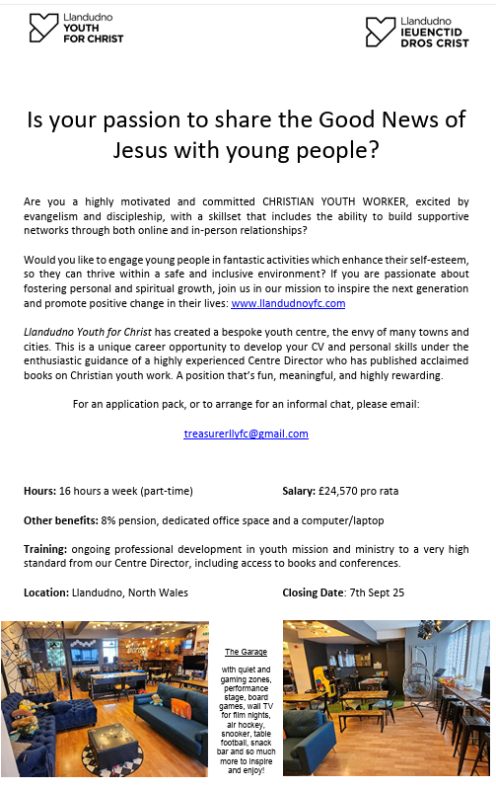
Questionnaire

As you may know, St John's Llandudno is in the midst of its market research to explore possible developments for the building. Would you be willing to complete the survey, please (if you haven't already)? Here is the link https://link.webropol.com/s/StJohnsLlandudno

Also - please would you pass on the link to anyone else who might be willing to fill in the questionnaire? We're looking for as wide a range of responses as possible - from church and non-church folk.

DATES FOR YOUR DIARY

Free Childrens’ packed lunches 12 – 12.30pm (no booking required)
13th August |  |  |  | Festival Church, Old Colwyn |  |  |  | Old Colwyn Churches together in conjunction with Home start and Morrisons
20th August |  |  |  | Old Colwyn Methodist Church
27th August |  |  |  | St Catherine’s & St John the Baptist Church in Wales, Old Colwyn
“Incredible Edible” at Old Colwyn Church

You don’t need to know anything about gardening to join in; just a willingness to get involved and eat cake!
Rake & Cake |  |  |  | 20th September |  |  |  | 10 – 12pm
Monday 11th–Saturday 30th August |  |  | Lego Exhibition |  |  | St Johns, Llandudno
Thursday 14th August |  |  | Closing date for Lay Community Worker post |  |  | St Johns Conwy  (See last week’s bulletin for details)
Sunday 10th August |  |  | Closing date for Finance officer post |  |  | St John’s Methodist Church, Llandudno  (See last week’s bulletin for details)
REGULAR EVENTS

Monday | Toddlers Sing and play |  |  |  |  |  | St Johns, Llandudno  09:45am -10:45am
 | Circuit Choir |  |  |  |  |  | St Davids, Craig y Don  4.00 - 5.00 pm
 | Hand Bell Ringers Practice  open to anyone |  |  |  |  |  | St Johns, Llandudno  12.30pm to 2pm
Tuesday | Coffee and reflection |  |  |  |  |  | St John's, Conwy  10.00 -12.00pm
 | Circuit Prayer Gathering |  |  |  |  |  | Llanddulas  10.30am
 | Circuit Prayer Gathering |  |  |  |  |  | Conwy  11.45am
 | Open House |  |  |  |  |  | St Davids Craig y Don  11am to 2pm
Wednesday | Coffee morning and reflection |  |  |  |  |  | St David's, Craig y Don  10.00am – 12.00pm
 | “Butterflies” Toddlers |  |  |  |  |  | St John's Conwy  9.30am-11.00am
Thursday | Circuit Prayer Gathering |  |  |  |  |  | Old Colwyn  10.30am
 | Prayers for Healing & Wholeness  (If you have any prayer requests, please bring on the day) |  |  |  |  |  | St John's, Llandudno  1:45pm-2:15pm
Friday | Circuit Prayer Gathering |  |  |  |  |  | St Johns, Llandudno  9.30am
 | Community Cafe |  |  |  |  |  | St Johns, Llandudno  10am-12pm
 | Trinity Toddlers |  |  |  |  |  | Trinity, Prestatyn  9.30am-11.00am
 | Toddlers Group |  |  |  |  |  | St Davids, Craig y Don  9.00am-11.00am
 | Warm welcome |  |  |  |  |  | St Johns, Llandudno  1.00pm – 4.00pm
USEFUL TO KNOW….
Superintendent |  | Rev Dr James Garnett  01492596006 |  |  | james.garnett@methodist.org.uk
Deacon Linda Brown |  | Deacon Linda Brown  01745 823732 |  |  | deaconlindabrown@gmail.com
Outreach worker |  | Liz Royle  07866177832 |  |  | cpmclayworkerlr@gmail.com
Childrens’ & Families worker |  | Jodie James  07886177560 |  |  | cpmclayworkerjj@gmail.com
Circuit Finance Office |  | Paula Hammond  01492878447 |  |  | cpmfinance2021@gmail.com
Circuit Administrator / Safeguarding |  | Hayley J. Allport  014920860439 |  |  | cpmcoffice2@gmail.com

Podcasts, Websites, Newsletters & Publications that may be of interest..

The Methodist Church | Click here to visit.
Our Circuit website | Click here to Visit
Methodist Property Matters | Click here to Visit
CTBI - Churches together in Britain and Ireland  Serving the churches of Britain and Ireland on the shared journey towards full visible unity in Christ. | Click here to visit.
All We Can - An international relief and development movement, rooted in the Christian faith. Together, we're finding solutions to poverty. | Click to visit
Cytûn - Churches together in Wales website | Click here to visit
The Well - For children, youth, schools and family workers | Click here to visit
JPIT - Joint Public Issues Team (Churches working for Peace and Justice) | Click here to visit
Fund for Human need | Click here to visit
Methodist Women in Britain | Click here to visit

