For members of our circuit and friends, please find the latest circuit news......
Remember that not everyone has access to the internet. Perhaps there are visitors to your church who may not be on our circulation list...
Please feel free to print out a few copies to spread the news!
Some churches have also included a link in their own newsletter which allows people to click to access the bulletin directly! Great idea!

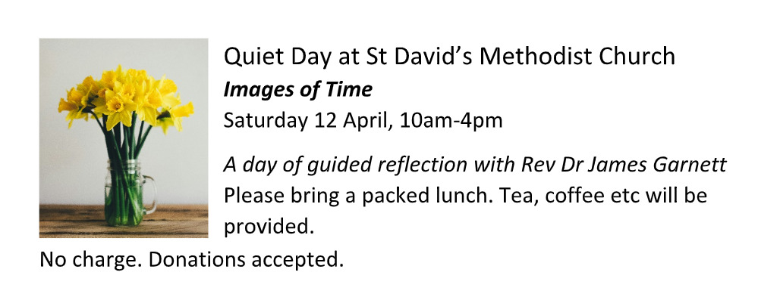

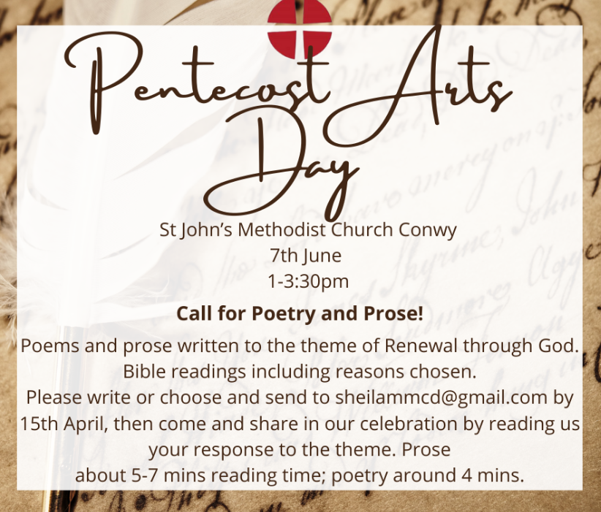

Myanmar Earthquake Appeal - Christian Aid

On Friday, Christian Aid launched a Myanmar Earthquake Appeal - Christian Aid. As you know, the devastation and human need is very great and our partners are responding under challenging circumstances.

Pray for those affected
God, our strength and our refuge,
We pray to you for the people of Myanmar.
We hold in mind those who are injured or have been bereaved.
We ask your protection for everyone awaiting rescue.
May those who have lost homes and belongings be comforted.
May emergency workers and medical staff be safe as they pour their energy
Into saving the lives of others.
May the international community respond quickly to support those affected.
God, our strength and our refuge,
Be with our global neighbours today.
Amen
David Shore
The funeral of David Shore will take place at Old Colwyn Methodist Church on the 14th April at 11.30am and then at Old Colwyn Crematorium at 12.30pm for anyone who may wish to attend.

Circuit Magazine
Please find the circuit magazine on our circuit website. Please consider writing for the next one and enjoy reading this one.

Pat Doherty
Pat's funeral will be on Thursday 24 April, 11.30 at St David's, followed by interment at 12.30pm at the Great Orme.

Songs of Praise: Renewal Through God
You are invited to take part in a Pentecost Circuit Service. This will be held on Sunday 8 June at St John’s Conwy at 6.30pm. We would like to invite you to contribute by way of hymn + testimony, and there will also be items from the Arts Day (See above for details of this)
Local Preacher long service certificates will be presented, and the circuit choir and a band will lead the singing. Please let Hayley or James know whether you would like to request a hymn, and a few sentences explaining why you have chosen it.


Wholehearted Monthly
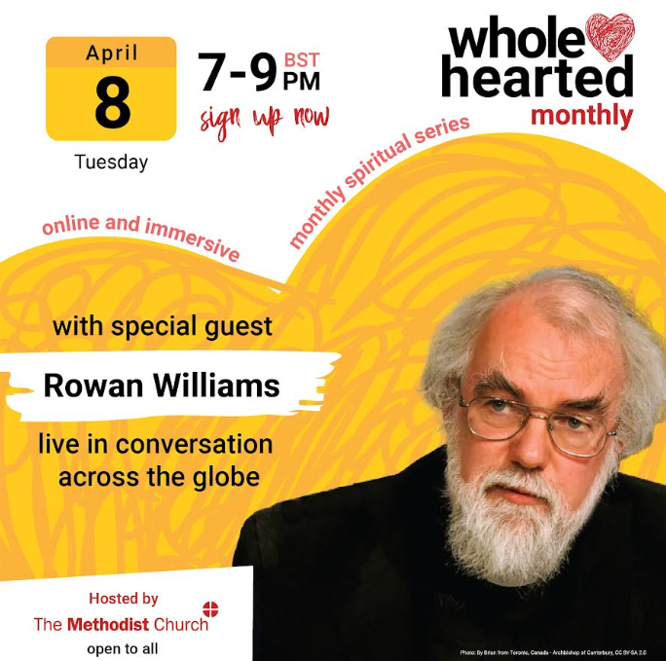 |  |  | The next meeting of 'Wholehearted Monthly', an online mission series, will be held next Tuesday April 8th at 7:00pm-9:00pm. There will be an address from Rowan Williams, then we will hold interest groups on various issues in the second half of the evening. Do have a look to see what’s available. We have set up a Welsh language discussion group to be held during the second hour. There is a warm welcome for all Welsh speakers to take part in this exciting opportunity.  Rowan Williams is a theologian, poet and former Archbishop of Canterbury, and the author of fifty books on literature, politics and Christianity.  It's all free. Register for the evening onhttps://www.eventbrite.co.uk/e/wholehearted-monthly-tickets-1082365166349?aff=evangelismgrowth
Free to a good home.. Office Desk

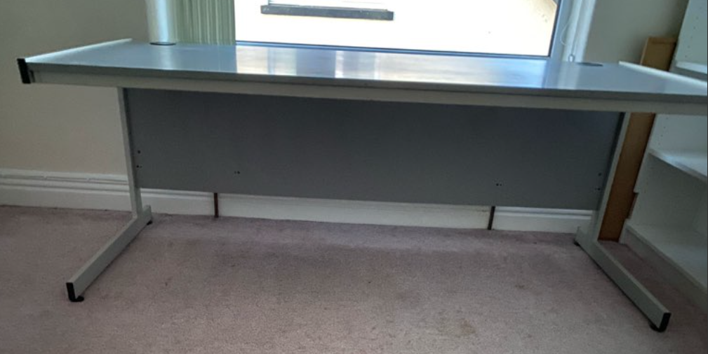

Good Friday Walk of witness

Cytun (Llandudno Churches Together) are reviving the traditional Good Friday Walk of witness which will be followed by a unified church service at Holy Trinity. The walk will start at 12 noon at the war memorial and come down the promenade and then to Holy Trinity via Clonmel Street. We are inviting as many of you as possible to join the walk so it becomes an effective witness. Those of you who would find the walk very difficult can join the service at approximately 12.20pm.
During the service there will be time for personal reflection and we would ask you to sign and/or comment on the sheet available at the back of the church which will be pinned to the cross during this time.
In the event of bad weather, the service will still take place inside Holy Trinity church beginning at 12.15
pm
DATES FOR YOUR DIARY

Wednesday evenings,  8-9pm  The first session will be on Wednesday 12th March, and the last on Wednesday 16th April. |  | Circuit Lent Bible Study: Growth in Christ  These studies will set the weekly Gospel readings alongside our continuing journey with Elijah this year.  Join for one or for the whole series |  |  | Zoom Link: Meeting ID: 849 6735 1356  Passcode: 210095 https://us02web.zoom.us/j/84967351356?pwd=NUgaH2eFa7kV1b2oJ5P68sqEJEra6u.1
Tuesday 7th April 7pm  St Paul’s Church, Colwyn Bay |  | “Waves of Hope”  A concert of spectacular music for Water aid  £10 admission on the door, children free |  |  | Please contact Ardal Cenhadaeth Aled Mission Area for more details
30th March – 5th April at Beechwood Court, Conwy |  | Music Week with Roger Jones  Spend the week enjoying great teaching, fellowship and music with the opportunity to perform or watch the performance of “ZAC” at the Presbyterian Church, Penrhyn Bay on Friday 4th April at 7pm |  |  | For more information contact events8@cmm.org.uk
Tuesday, 6th May - Friday, 9th May. |  | Keswick Bible Week  ‘The Sensational Newness of the Good News’ |  |  | Contact Carol Reynolds, on behalf of the Bible Week organising committee
REGULAR EVENTS

Monday |  | Toddlers Sing and play |  |  | St Johns, Llandudno  09:45am -10:45am
 |  | Circuit Choir |  |  | St Davids, Craig y Don  4.00 - 5.00 pm
 |  | Hand Bell Ringers Practice  open to anyone |  |  | St Johns, Llandudno  12.30pm to 2pm
Tuesday |  | Coffee and reflection |  |  | St John's, Conwy  10.00 -12.00pm
 |  | Circuit Prayer Gathering |  |  | Llanddulas  10.30am
 |  | Circuit Prayer Gathering |  |  | Conwy  11.45am
 |  | Open House |  |  | St Davids Craig y Don  11am to 2pm
Wednesday |  | Coffee morning and reflection |  |  | St David's, Craig y Don  10.00am – 12.00pm
 |  | “Butterflies” Toddlers |  |  | St John's Conwy  9.30am-11.00am
Thursday |  | Circuit Prayer Gathering |  |  | Old Colwyn  10.30am
 |  | Prayers for Healing & Wholeness  (If you have any prayer requests please bring on the day or send them to eldensmall376@gmail.com) |  |  | St John's, Llandudno  1:45pm-2:15pm
Friday |  | Circuit Prayer Gathering |  |  | St Johns, Llandudno  9.30am
 |  | Community Cafe |  |  | St Johns, Llandudno  10am-12pm
 |  | Trinity Toddlers |  |  | Trinity, Prestatyn  9.30am-11.00am
 |  | Toddlers Group |  |  | St Davids, Craig y Don  9.00am-11.00am
 |  | Warm welcome |  |  | St Johns, Llandudno  1.00pm – 4.00pm
USEFUL TO KNOW….
Superintendent | Rev Dr James Garnett  01492596006 |  |  | james.garnett@methodist.org.uk
Deacon Linda Brown | Deacon Linda Brown  01745 823732 |  |  | deaconlindabrown@gmail.com
Outreach worker | Liz Royle  07866177832 |  |  | cpmclayworkerlr@gmail.com
Childrens’ & Families worker | Jodie James  07886177560 |  |  | cpmclayworkerjj@gmail.com
Circuit Finance Office | Paula Hammond  01492878447 |  |  | cpmfinance2021@gmail.com
Circuit Administrator / Safeguarding | Hayley J. Allport  014920860439 |  |  | cpmcoffice2@gmail.com
A Message from Meaningful Chocolate Company
We invite you to take part in this year’s Real Easter Egg campaign.
In 2010 churches helped found The Meaningful Chocolate Company by placing orders for the first Real Easter Eggs.
We still rely on our supporters to encourage people to buy a Real Easter Egg for family and friends as a simple way of sharing the Good News. The Real Easter Egg is the only Fairtrade egg which includes a 24 page copy of the Easter story in each box and which supports charitable projects.
How you can help
Last year hundreds of churches placed orders directly with us in quantities ranging from 12-1,000 eggs. For the past 15 years, we have relied on people being champions by buying direct from us, spreading the word and encouraging others to buy. Direct sales are very important for our company to trade. This year we are offering four ways to buy from us:
- Be a Champion and collect orders from family and friends and order a case from us
- Buy a case to share with friends, family or a school
- Send single eggs in any numbers direct through the post
- Sponsor an egg, case or pallet to be sent to a food bank
A gift for individuals and groups
This year there are five types of Eggs designed as personal gifts and there is also our sharing box designed for larger events or for giveaways or goody bags. Each egg has a new edition of the Easter story in the box. The Original, Dark, Mugs and Fun Packs are designed to be a personal gift for people of all ages. For people looking to buy for Children’s Easter events, Messy Church or for outreach giveaways, we have our Sharing Boxes.
Real Easter Egg Competition.
Inside each of our Easter story books there is a chance to win £200 worth of book tokens. The story books come free with our Original, and Dark eggs. The competition is open to all young people. There are two categories: Junior and Senior. All the entrant has to do is answer some general knowledge questions about Easter which are at the back of the book.
There is a first prize of £50 in book tokens in each category and two runner up prizes of £25 worth of tokens in each category. All entries with correct answers will be entered into the prize draw.
Entries need to be with us by 6th May 2025 Details here.


Podcasts, Websites, Newsletters & Publications that may be of interest..
The Methodist Church | Click here to visit.
Our Circuit website | Click here to Visit
Methodist Property Matters | Click here to Visit
CTBI - Churches together in Britain and Ireland  Serving the churches of Britain and Ireland on the shared journey towards full visible unity in Christ. | Click here to visit.
All We Can - An international relief and development movement, rooted in the Christian faith. Together, we're finding solutions to poverty. | Click to visit
Cytûn - Churches together in Wales website | Click here to visit
The Well - For children, youth, schools and family workers | Click here to visit
JPIT - Joint Public Issues Team (Churches working for Peace and Justice) | Click here to visit

