Match funding opportunities for 2024

Green Match Fund 2024
Our Green Match Fund aims to support charities playing a vital role in addressing pressing environmental issues. Whether that’s preserving ecosystems, protecting endangered species or promoting sustainable practices, every donation will make double the difference in the global effort to protect and preserve our planet.

We’re calling all charities working on environmental issues in the UK or overseas as part of their core mission. (By “core mission”, we mean that the environment is mentioned in the organisation’s charitable objects. This may include biodiversity & conservation, climate change, agriculture & food, sustainable communities, energy, transport, trade & finance, consumption & waste, toxics & pollution).
Charities have two different models they can choose to apply for. Charities seeking to raise:
- Up to £10,000 in public donations (to be doubled by match funds) through the 1:1 model.
- Up to £100,000 in public donations (to be doubled by match funds) through the pledge model. Charities can receive up to £50k in Champion funds.

You can watch and share this webinar to understand how the multi-model campaign works. Applications are open now and close on Tuesday, 16th January. You can find further information on the Green Match Fund page here.

Christian Aid Trustee and Wales Chair Role Job Profile
Blwyddyn Newydd Dda i chi gyd. Please find attached the Christian Aid trustee and Wales chair profile. You can access the information on the circuit website or by contacting Hayley James, circuit admin at CPMC.
To apply, please send an email to vlclark@christian-aid.org with an up-to-date CV and a supporting cover letter addressed to Martin Birch, Company Secretary. The cover letter should reference the person specification, outline their motivation for joining the Board of Christian Aid and include details of relevant experience, achievements and responsibilities.
Applications will close on 19th January 2024 and candidates will be invited to meet a selection panel soon after. Thereafter, recommendations for appointment will be proposed to the Board of Trustees and formally ratified at the Annual General Meeting of Sponsoring Churches in November 2024.
Andrew Sully
Pennaeth Cymorth Cristnogol Cymru / Head of Christian Aid Wales

A Message from Nancy, Conwy Food Bank
We are so grateful for any items as we are short on everything now. Coffee; Sugar; Tinned Meat Meals; Cold Meats; Tins of Fruit; Tins of Tuna; Packet Pasta in Sauces; Savoury Rice; Custard; Rice Pudding; Jam; Marmalade etc.
Thank you for your continued support to Conwy Food Bank it really is very
much appreciated .

Week of Prayer for Christian Unity 2024
Services in our local churches
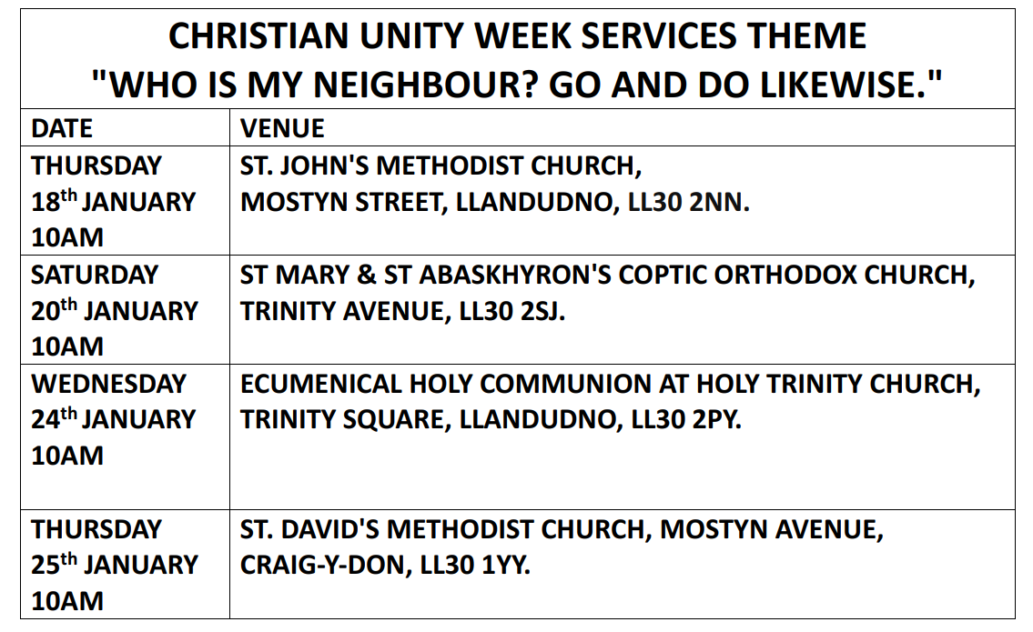
A Message from Dave Martin, Local Preachers’ Secretary
It is with sadness that I inform you all of the death of one of our local preachers, Ron Jones.
Ron was accredited as a local preacher in 1979. The thanksgiving service for his life will be held at St John's Llandudno on Friday 26th January at 11.00 am. I am sure that our prayers are with the family at this time.

Advanced Safeguarding Training
This will be available online on January 31st 2024. Please can you let Hayley and your church safeguarding officer know if you register so we can update records? You can book here:
Reading Glasses

If you have any reading glasses, preferably with cases, that you no longer use, please pass them onto Mary Jones of St Johns, Llandudno. She will pass them on to Barnabasaid who distribute them on to persecuted and suffering Christians.
Join In This Brand New Fundraising Challenge
The idea is simple: do all the *something* you can in January 2024, and fundraise for “All We Can” in the process!

Whether it be running all the miles you can, reading all the books you can, or knitting all the hats you can - it’s up to you what challenge you set yourself, because only you know what you need to fulfil your potential.

In the process, you’ll have the chance to learn and share inspiring stories from All We Can’s local partners in Liberia. As they fulfil their potential, journey with them as you seek to fulfil yours!

This is a challenge anyone can get involved with:
Need a little extra motivation for your New Year’s resolution? Turn it into a fundraising challenge!
Don’t want to do it alone? Take part as a group from your church or school.
Can’t commit to a month-long challenge? Organise a one-off event which features doing the most of an activity you can.

FIND OUT MORE HERE AND SIGN-UP

Circuit Prayer Gatherings

Saturday 3rd February | Trinity Prestatyn 9.30am with breakfast |  |  | Please contact Deacon Linda for more information.
Sunday 7th April | St Davids Craig y Don 7.15pm
Friday 3rd May | St. Johns Llandudno 9.30am with breakfast
Sunday 12th May | St Davids Craig y Don 7.15pm
Saturday Space
Numbers will be limited to 6 people
 | At:  Ruach Retreat Llys Gwynt,  Old Mill Road, Dwygyfylchi, LL34 6TB |  |  | 9.45am until 12.30pm
Phone: 01492 622279.
Email: dray1@btinternet.com
20th January
17th February
16th March
Prayers for Healing and Wholeness
Please pray for those who come and please join us if you are able.

Every Thursday |  | St Johns Church,  Llandudno Ll30 2NN  1.45pm-2.15pm | If you have any prayer requests please bring on the day or send them to eldensmall376@gmail.com
The Third Thursday
Simple supper and chat . If you are able, we ask for a donation of £5 towards the food
Numbers will be limited to 6 people.
Thursday 18th January | At:  Ruach Retreat Llys Gwynt,  Old Mill Road, Dwygyfylchi, LL34 6TB |  |  | Please book no later than the previous Monday.  Phone: 01492 622279. Email: dray1@btinternet.com
Thursday 15th February
Thursday 21st March

6.30pm - 8.00pm

Podcasts, Websites, Newsletters & Publications that may be of interest.. (*=Newly updated)

The Methodist Church | Click here to visit.
Our Circuit website | Click here to Visit
Methodist Property Matters | Click here to Visit
CTBI - Churches together in Britain and Ireland  Serving the churches of Britain and Ireland on the shared journey towards full visible unity in Christ. | Click here to visit.
All We Can - An international relief and development movement, rooted in the Christian faith. Together, we're finding solutions to poverty. | Click to visit
Cytûn - Churches together in Wales website | Click here to visit
The Well - For children, youth, schools and family workers | Click here to visit
JPIT - Joint Public Issues Team (Churches working for Peace and Justice) | Click here to visit

